Enrich Academy
Behaviour and Relational Policy

Date | Version | Action | Summary of changes
07/07/2023 | 1.0 | Major policy revision | Re-write of behaviour policy

Contents

Section | Description | Page
Contents
Introduction 3
1. Aims 3
2. Legislation and Statutory Requirements 3
3. Definitions 4
4. Child on Child Abuse 5
5. Roles and Responsibilities 5
5.1 The Board of Trustees and CEO 5
5.2 The Head Teacher 5
5.3 Staff 6
5.4 Parents 7
6. Pupil Conduct 7
7. Uniform 7
8. Rewards and Actions 7
8.1 List of Rewards and Regulation 7
8.2 Suspensions 9
8.3 Off-Site Behaviour 9
8.4 Malicious Allegations 9
9. Behaviour Management 9
9.1 Classroom Management 9
9.2 Positive Handling 10
9.3 Confiscation 11
9.4 Pupil Support 11
9.5 Supporting Behaviour Through the Curriculum 12
9.6 Absconding 13
10. Pupil Transition 13
11. Part-Time Timetables 13
12.Training 14
13. Monitoring arrangements 14
13.1 Reviewing the impact of behaviour systems 14
14.Links with other policies 14
1. Appendix i – Learning Expectations & Graduated Approach 15
2. Appendix ii - Missing from School Response Checklist 18
3. Appendix iii – Support to Self-Regulate Plan 19
4. Appendix iv - Class Team Debrief 23
5. Appendix v - Ethos Academy Trust Behaviour Principles Statement 25
6. Appendix vi – Classroom Reward Displays 28
7. Appendix vii – Reintegration Log 30
8. Appendix viii – Team Teach Information Sheet 33
9. Notes 34

Behaviour and Relational Policy

Introduction
Enrich Academy educates and supports pupils with a wide spectrum of need in a variety of contexts. Social, Emotional and Mental Health (SEMH) needs are central to this relational policy and we are working towards a nurture approach being used across school. This document outlines both the philosophy and practice that informs our work. It aims to provide a practical guide for all stakeholders in managing, assessing and meeting individual needs. The procedures and guidance in this document reflect the consistent approach taken across the Academy and supports pupils, parents and staff to understand our approaches to the management of behaviour in school. Enrich is part of Ethos Academy Trust, please see Appendix v for our Trust agreed behaviour principles.
Enrich Academy is committed to inclusive education and securing the greatest possible access to learning and achievement for pupils with SEMH and other Special Educational Needs and Disabilities (SEND). It is also recognised that for some pupils, variance of the procedures will be needed to meet any specific SEMH, learning or needs which require a personalised approach.
The most important aspect in children feeling valued, safe and secure is the sense of connection with a member of staff. For most children, this can be achieved by simple acknowledgement of the child and the child having the knowledge that you have them in your mind, care about them as a person and care about what they are doing.

Aims
The main aim of Enrich Academy is to work in partnership with schools, parents/carers and external agencies to achieve positive outcomes for pupils with SEMH difficulties. To achieve this aim, staff at Enrich Academy will:
- Offer a curriculum that enables all pupils to engage with and enjoy their learning, where every pupil achieves positive outcomes and develops future aspirations;
- Provide a positive experience of education for those who have been permanently excluded or are at risk of being permanently excluded from school;
- Provide a nurturing environment and experience for all pupils; including personal development opportunities, accessing experiences that build cultural capital and preparation for transition and adulthood.
- Assist pupils in gaining skills and knowledge to enable them to make positive contributions to the school community and wider society;
- Assess and address SEMH needs in addition to any other SEND that acts as a barrier to learning;
- Model and apply The Graduated Approach (see Appendix i) to assess, apply and review pupils’ needs in order to enable parents, families, schools and other agencies to provide an education that fully supports individual need.
Our curriculum is designed to support pupils returning to mainstream school through a broad and balanced offer. Pupils access core and non-core subjects in line with the National Curriculum alongside lessons and personalised interventions to support pupils’ personal development and specific SEMH and learning needs. Weekly cooking sessions, health and fitness sessions, are also planned to develop pupils’ life skills and outdoor education and community projects are on offer to some pupils to enhance their ability to be responsible citizens within the school community and their wider communities. The curriculum and culture across Enrich Academy is being developed to embed a nurture-based approach, that is underpinned by the 6 Principles of Nurture:
1. Children's learning is understood developmentally
2. The classroom offers a safe base
3. The importance of nurture for the development of wellbeing
4. Language is a vital means of communication
5. All behaviour is communication
6. The importance of transition in children's lives
Further information around our curriculum can be found on our website: Curriculum - Enrich Academy.

Legislation and Statutory Requirements
This policy is based on advice from the Department for Education (DfE) on:
- Behaviour and discipline in schools
- Searching, screening and confiscation at school
- The Equality Act 2010
- Use of reasonable force in schools
- Supporting pupils with medical conditions at school
In addition, this policy is based on:
- Special Educational Needs and Disability (SEND) code of practice
- DfE guidance explaining that academies should publish their behaviour policy and anti-bullying strategy online

Definitions
At Enrich Academy, the learning expectations give protection to core rights and are regularly discussed with pupils and staff. Expectations are clear, positively phrased, fair, reasonable and unambiguous. When staff are supporting pupils with undesirable behaviour, reference should be made to which learning expectation is not being adhered to (see Appendix i). The school expectations have been created in consultation with staff and students).
Learning expectations are defined as:
- Arrive on time and be ready to learn
- Use positive language
- Allow other students to learn
- Show positive effort and attitude
- Complete all tasks to the best of my ability

Non-negotiables are defined as:
- Repeated breaches of the school rules
- Use of mobile devices on site
- Any form of bullying
- Sexual assault, which is any unwanted sexual behaviour that causes humiliation, pain, fear or intimidation
- Vandalism
- Theft
- Physical assault
- Smoking (Including Vaping)
- Racist, sexist, homophobic or discriminatory behaviour
- Possession of any prohibited items. These are:
  - Knives or weapons
  - Alcohol
  - Illegal drugs
  - Stolen items
  - Tobacco, cigarette papers and vapes/ e-cigs
  - Fireworks
  - Pornographic images and youth produced imagery
  - Any article a staff member reasonably suspects has been, or is likely to be, used to commit an offence, or to cause personal injury to, or damage to the property of, any person (including the pupil)

Child on Child Abuse
It is important to recognise that abuse is not always perpetrated by adults; children can abuse other children and it can happen both inside and outside of educational settings and online. This is referred to as 'child on child abuse' and can include:
- Bullying, including cyberbullying, prejudice-based and discriminatory bullying;
- Hate crimes and hate incidents, such as one-off serious incidents or ongoing bullying with a racist, faith targeted, homophobic, bi-phobic, transphobic content or targeting disability and/ or additional needs;
- Abuse in intimate personal relationships between peers;
- Physical abuse such as hitting, kicking, shaking, biting, hair pulling, or otherwise causing physical harm; this may include an online element which facilitates, threatens and/or encourages physical abuse;
- Sexual violence, such as rape, assault by penetration and sexual assault; this may include an online element which facilitates, threatens and/or encourages sexual violence;
- Sexual harassment, such as sexual comments, remarks, jokes, and online sexual harassment, which may be standalone or part of a broader pattern of abuse;
- Causing someone to engage in sexual activity without consent;
- Consensual and non-consensual sharing of nude and semi-nude images and or videos (also known as sexting or youth produced sexual imagery);
- ‘Upskirting’ which involves taking a picture under someone’s clothing without them knowing; this is usually with the intention of viewing their genitals or buttocks for sexual gratification, or cause the victim humiliation, distress, or alarm. Upskirting is a criminal offence and anyone, of any gender, can be a victim;
- Initiation/hazing type violence and rituals.
Details of our approach to preventing and addressing bullying are set out in the Trusts’ Anti -Bullying Policy.

Roles and Responsibilities

5.1 The Board of Trustees and CEO
Ethos Academy Trust and the CEO will review this behaviour and relational policy in conjunction with the Head Teacher and monitor the policy’s effectiveness, holding the Head Teacher to account for its implementation. The board is responsible for reviewing and approving the written statement of behaviour principles.

5.2 The Head Teacher
The Head Teacher is responsible for reviewing this relational policy in conjunction with the Trust Board, giving due consideration to the school’s statement of behaviour principles.
The Head Teacher will ensure that the school environment encourages positive behaviour, that staff deal effectively with poor behaviour and monitor how staff implement this policy to ensure rewards and consequences are applied consistently.

5.3 Staff
Staff are responsible for:

- Implementing the relational policy consistently;
  - Staff will be guided and supported in understanding this policy at regular intervals throughout the year
- Modelling positive behaviour and building positive relationships;
  - Staff will be provided with training in ‘Unconditional Positive Regard’ and ‘Trauma Informed Practice’ to support them in developing a relational approach
- Providing a personalised approach to the specific needs of pupils;
  - Staff will be supported in developing plans to meet students’ individual needs. Where appropriate, they will be provided with training as required and systems will be developed to share good practice between form tutors and class teachers
- Monitoring, recording and following up incidents;
  - The end of the day will be structured to ensure staff can do this timley:
2:00 – 2:30, All staff will record any behaviour concerns, positive behaviours and record behaviour points for that day;
2:30 – 3:00, All staff will meet in groups to review behaviour logs, complete a ‘Daily Debrief’ document and carry out any relevant follow up actions including passing on any relevant information to all staff, DSL Team, Behaviour Support Team and SLT
- Being in the right place at the right time e.g., meet and greet, start of lessons
  - A staff rota is established which will outline:
    - The role of the Behaviour Support Team in welcoming students at the gate and communicating with all staff via the radio as each individual pupil arrives – this will indicate to staff who has arrived on site. If the pupil does not arrive at their form group, or in their classes throughout the day, staff members MUST follow the ‘Missing from School Response Checklist’ (See Appendix ii);
    - The role of the TA between 8:30 – 9 to ensure that pupils are welcomed into school, greeted positively and are escorted to the social area orderly and then to their form rooms at 9:00 promptly
    - The role of behaviour support in collecting in items such as mobile phones, vapes, prohibited items, wanding pupils (see section 9.3) and returning items at the end of the day
    - The role of all staff in escorting pupils to the next lesson throughout the day and encouraging appropriate behaviour between lessons
    - The role of all staff on duty during year 10 break time, year 11 break time, lunch time and dismissal. Duty points throughout the school and expectations of staff and students are outlined in the ‘Guide for Form Tutors’ document to ensure consistency during these times. All staff are able to allocate form points to students where positive behaviours are displayed throughout the day.
    - The locations for each of these points and expectations of staff during these times
The Senior Leadership Team and Behaviour Support Team will support staff in responding to periods of dysregulation and modelling positive relationships.

5.4 Parents
Parents are expected to:
- Inform the school of any changes in circumstances that may affect their child’s emotional state
- Discuss any concerns with a key member of staff promptly and attend review and reintegration meetings as required

Pupil Conduct
At Enrich Academy, staff want to ensure that every pupil is successful and is offered a rich and varied curriculum that supports the social, emotional and mental health needs of our pupils.
Pupils are expected to:
- Arrive on time and be ready to learn
- Use positive language
- Allow other students to learn
- Show a positive effort and attitude
- Complete all tasks to the best of their ability

Uniform
Enrich Academy has a school uniform that all pupils must wear. At the of start of the year, all pupils will be provided with an Enrich Academy jumper/hoody and T-shirt when they start. There will be the option to purchase more if required. Parents/carers are responsible for ensuring their child attends each day wearing the following:
- Appropriate black joggers/leggings/shorts
- Enrich Academy jumper/hoody
- Enrich Academy T-shirt
- Suitable shoes/trainers/boots

Rewards and Actions
A reward is positive feedback given to students. A reward will reinforce, encourage and motivate future positive presentation and relationships with pupils.
At all times, staff at Enrich Academy seek to encourage pupils, having high aspirations for all. Encouragement includes any action that conveys to the pupil that staff respect, trust, and believe in his/her value as a person.

8.1 List of Rewards and Regulation
Positive behaviour will be rewarded with:
- Praise
- Phone calls home to parents
- Special responsibilities/privileges
- Post cards home
- Daily form points
- Achievement points
- Communal form points
- Monetary rewards for designated venues including supermarket vouchers, treats at local food outlets and other shops linked to pupil hobbies
- Rewards trips at the end of each half term

The school will use a variety of strategies to support dysregulation and behaviour management, including:
- Verbal reminders
- Brain breaks
- Change of face
- Use of time out in well-being room, with the behaviour support team or a mutually agreed safe space
- Support from senior members of staff
- Consistent approach from all members of staff
- Phone calls home to parents
- Use of emotional coaching scripts
- Agreeing a behaviour contract with parents as part of a reintegration meeting
- Review of a pupil’s SEMH assessment, including strategies and interventions
- Individually tailored plans
- Restorative approaches
- Curriculum content including the impact of cyberbullying, prejudice-based and discriminatory bullying
- Modelling of appropriate behaviours by staff including through the RSE/PHSE curriculum and reflection opportunities at allocated times i.e.at the start and end of the day with form tutor
- Expecting work to be completed at a later time
We may use one to one interventions, offsite intervention or suspension (in exceptional circumstances) in response to serious or persistent breaches of this policy. In the event of a serious breach of the policy school may contact the police.

8.2 Suspensions
The focus on positive behaviour, forgiveness and reconciliation will significantly reduce the need for suspension. Alternatives to suspensions are always sought, where possible, and the emphasis remains on ensuring pupils are offered an appropriate timetable, personalised to their individual needs. However, when considering appropriate next steps, including sanctions, the Head Teacher must balance the needs of the individual with those of the wider school community and where pupil behaviour places others at risk, the safety of themselves and others is paramount. The academy strongly feel that suspensions must be used only as a very last resort. On rare occasions, fixed term suspensions are issued and carried out in line with the current DfE suspensions guidance which states that only Head Teachers have the authority to suspend students; on these occasions a structured re-integration meeting takes place which involves a member of the Senior Leadership Team and/ or Behaviour Support Team, pupil and their families. For those pupils with an EHCP, Enrich Academy will liaise with SENCO to consider how we can continue to meet the pupils needs. A record of this meeting will be kept on the Reintegration Log (Appendix vii).

8.3 Off-Site Behaviour
Rewards and actions will continue to be applied when representing the school offsite, such as on a school trip or on the way to or from school, as appropriate to the situation. Any incident will be investigated with all parties involved, with the relevant action applied.

8.4 Malicious Allegations
Where a pupil makes an accusation against a member of staff and that accusation is shown to have been malicious, the Head Teacher will meet with staff, parents and pupils involved to consider appropriate sanctions. This will be in conjunction with the Trust’s Safeguarding and Child Protection Policy and Managing Allegations Policy.
The Head Teacher will also consider the pastoral needs of staff accused of misconduct. Where possible, restorative approaches will be explored to repair relationships.

Behaviour Management

9.1 Classroom Management
Teaching and support staff are responsible for modelling and setting the ethos and context for positive behaviour within the classroom.
They will:
- Create and maintain a stimulating environment that encourages pupils to be engaged;
- Display the pupil learning expectations in classrooms;
- Display Rewards System in classrooms i.e. How points can be earned, what points can be used for, a points tracker, what points can be converted for (See classroom Reward displays in Appendix vi) Please note, the style of these displays can be amended to suit individual classes, but the content will remain the same.
- Develop a positive relationship with pupils, which will include:
  - Greeting pupils in the morning and at the start of lessons
  - Establishing clear routines
  - Communicating expectations of behaviour in ways other than verbally
  - Highlighting and promoting good behaviour
  - Concluding the day positively and starting the next day afresh
  - Using effective strategies for dealing with low-level disruption
  - Using positive reinforcement/ set language scripts
  - Differentiating work that enables and scaffolds learning
  - Receiving training on behaviour management from experienced staff and from relevant external agencies including the educational psychology service and CAMHs
  - Effective line management, which provides feedback on outcomes from learning walks and annual CPD audits that staff can access and request support to improve their practice
Pupil performance throughout the day will be recorded on Arbor. Staff are provided with dedicated time to log behaviour directly after students are dismissed (See section 5.3).

Where concerning behaviours are frequent or significant, SLT will join debrief discussions (where appropriate) and additional discussion and follow up will take place to unpack the concerns in more depth and explore further actions and interventions.

9.2 Positive Handling
In some circumstances, staff may use positive handling (Team Teach) to prevent pupils from putting themselves or others at risk of harm or damaging. Further information can be found in Ethos Academy Trusts Positive Handling Policy and in Appendix viii.

Incidents of positive handling must:
- Always be used as a last resort when all other de-escalation strategies have been exhausted;
- Be applied using the minimum amount of force and for the minimum amount of time possible;
- Be used in a way that maintains the safety and dignity of all concerned;
- Never be used as a form of punishment;
- Be recorded on Arbor and reported to parents/carers on the same day;
- Always be followed up with a restorative conversation facilitated by a trained staff member to ensure the relationship between the pupil and staff involved is maintained;
- Follow Team Teach techniques as per Team Teach training received by all staff.

9.3 Confiscation
Any prohibited items (listed in section 3) found in pupils’ possession will be confiscated. These items will not be returned to pupils.
We will also confiscate any item which could potentially be harmful or detrimental to staff or pupils. These items will be returned to pupils at the end of the school day, after discussion with senior leaders and parents, if appropriate.
All pupils are screened with a metal detecting wand before they enter the Academy. If staff feel that a pupil may have a prohibited item and a search is required, this will be authorised by the Head Teacher; the staff carrying out the search will be the same sex as the pupil being searched and will have received the necessary training; a witness (also a staff member) will be present; the location will be appropriate.
As per Government guidance staff will aim to get the pupil’s cooperation before searching them. However, if the pupil does not cooperate, the staff member can still search them if there’s a risk of serious harm. Click here to see further Government guidance on searches for banned items.
All searching and screening pupils is conducted in line with the DfE’s latest guidance on searching, screening and confiscation.

9.4 Pupil Support
The school recognises its legal duty under the Equality Act 2010 to prevent pupils with a protected characteristic from being at a disadvantage. Consequently, our approach to challenging behaviour is differentiated to cater to the needs of the pupil.
Through the use of the Boxall SEMH assessments, specific interventions and strategies are used to meet the needs of the pupils. These interventions include but are not limited to:
- Social stories
- ELSA Support
- Circle of friends
- Zones of regulation
- Restorative practices
Pupils can also access support from external agencies offering health, wellbeing and therapeutic services.
The school’s Special Educational Needs Co-ordinator and Deputy will work alongside colleagues to initiate external assessments where needed for pupils exhibiting high levels of challenging behaviour. Where necessary, support and advice will also be sought from specialist teachers, an educational psychologist, medical practitioners and/or others, to identify or support specific needs.
When acute needs are identified in a pupil, we will liaise with external agencies and plan support programmes in line with our SEN policy and practice. For pupils who are at risk of, or engaged in, criminal and risky behaviour, referrals will be discussed with the pupil and parents for BASE, St Giles, Early Help, Yorkshire Mentoring Services and other services specific to the pupil's need.

Effective restorative meetings
A restorative meeting is not just a meeting or a set of questions, it is a way of working with people to manage, correct and restore positive relationships. A restorative meeting will take place, whenever possible, when a negative incident takes place between two or more parties. The meeting will be facilitated by a staff member who has had appropriate training in restorative practices. The aim of a restorative meeting is to:
- Understand the reasons for a person’s behaviour;
- Put your own views across;
- Help the person understand the impact of their behaviour on others;
- Restore the relationships;
- Identify ways to prevent this happening again in future.
Prior to speaking to the pupil:
- Spend some time reflecting on the incident and see how you could have helped to prevent this;
- Plan what you want to say, so that you can put across your thoughts calmly and articulately;
- Ensure you are in a calm state and are receptive to hearing what the other person has to say;
- Ensure you have enough time to meet the pupil;
- Plan where the meeting will be held so that it can be a calm and purposeful meeting.
When speaking to the pupil ask the following:
- What happened?
- What were you thinking?
- What have you thought since? (Their last word isn’t their last thought)
- Who suffered as a result?
- What do we need to do put things right?
It is important that, as the adult, an apology from the pupil is accepted and a willingness to restore the relationship is evident. The pupil needs to know that the next lesson/day will be a fresh start.

Supporting Behaviour Through the Curriculum

At Enrich, addressing behaviour is an integral part of our curriculum and overall approach to fostering a safe and nurturing learning environment. We monitor the behaviour log to document incidents and identify trends, enabling us to plan targeted interventions. These interventions are designed to cater to the unique needs of both individuals and the entire school community. In cases where we observe an increase in specific issues, such as hate crime incidents, we proactively collaborate with external providers who conduct enlightening sessions for the entire school. In addition, for more personalised concerns, we arrange specialised services to visit our school. For instance, we've had the Fire Service visit to address worries related to fire alarms, ensuring our pupils receive comprehensive education on safety and responsibility. Our commitment to addressing behaviour extends beyond the classroom, promoting a holistic and inclusive approach to student well-being.

9.6 Absconding
To abscond is to leave site without permission. If a pupil leaves site without permission, the Trust’s absconding procedures must be adhered to (see Appendix ii). Any incidents of absconding must be recording on CPOMS as soon as possible after the incident. The police will be informed where there are highlighted additional risks.

Pupil Transition
Pupil transition upon start of their placement will be supported using the guidance in this policy. At Enrich Academy, staff understand the importance of transition and provide personalised interventions to support transition at the beginning and end of their placement. Where necessary, pupils will spend an agreed amount of time, up to 2 weeks, on their transition. They will then be placed into a group that is best placed to meet their needs. Reasonable adjustments are made for pupils experiencing a period of transition and strategies that work well to support positive behaviour are shared with a pupil’s receiving school through their re-integration support plan, My Support Plan/ EHCP (if applicable), Support to Self-Regulate Plan (see Appendix iii) and exit report.

11. Part-Time Timetables
At Enrich Academy, all teaching and non-teaching staff have responsibility for the care of pupils who are struggling to access learning. We recognise however, that at certain stages in a child or young person’s school life they may struggle to access the typical provision offered as a result of their Social, Emotional and Mental Health needs. Even when the curriculum is reasonably adapted in line with best teaching and learning practice and the young person is appropriately supported within our usual systems, there are occasions when a pupil may still struggle to access full time education. In these instances, the Head Teacher may consider that a personalised timetable is an appropriate means of supporting the young person up until the point when they are better able to access full time education. Personalised timetables are reviewed on a fortnightly basis and the both the pupils and their parents/ carers view are considered. Their views and progress made whilst on the Personalised Timetable are then discussed at a Provisions meeting which is attended by members of SLT, DSL and SEN and Behaviour Support teams. This discussion takes place before determining whether changes will be made to their timetable.
Examples of when this is appropriate may include:
• When the child or young person has repeated or prolonged episodes of crisis when in school;
• When a risk assessment is required if there is a significant health and safety risk to themselves, other pupils or staff which cannot be reasonably managed within the usual day
If the Head Teacher considers a personalised timetable is appropriate, a clear plan for this will be completed in line with Wakefield guidelines. This plan and the reasons for it, will be communicated to parents and carers along with the arrangements for its regular review. The aim of a personalised timetable will always be to support the young person so that they can return to full time education as soon as possible. The duration will, however depend on the needs of the individual but will remain in place for the shortest time necessary.
Enrich Academy will inform Wakefield Education Safeguarding Service when using reduced timetables for pupils and follow the Wakefield reduced timetable guidance.

12.Training
Our staff are provided with training on understanding and managing behaviour, including the use of Team Teach, trauma informed approaches, unconditional positive regard, identification of SEMH needs and strategies to support needs and behaviour management. This training is regularly updated throughout the year and is part of our Continual Professional Development program.

13. Monitoring arrangements
This behaviour policy will be reviewed by the Head Teacher and the Board of Trustees every year. The written statement of behaviour principles will be reviewed by SLT on an annual basis in conjunction with this policy.

13.1 Reviewing the impact of behaviour systems
The behavior log on Arbor is reviewed daily, and actions are promptly implemented to provide support to students in order to address their behaviors effectively. After a suspension, a student's support plan may be revised, if necessary. If positive handling techniques have been employed, the student’s regulation plan is also updated accordingly. Additionally, all other behavior systems, including form points, achievement points, and attendance rewards, undergo comprehensive analysis and review on a termly basis.

14.Links with other policies
This behaviour policy is linked to the following policies:
- Safeguarding and Child Protection Policy
- Managing Allegation Policy
- Anti-Bullying Policy
- Behaviour Principles
- Positive Handling Policy

Appendix i – Learning Expectations & Graduated Approach

Learning Expectations
- Arrive on time and be ready to learn
- Use positive language
- Allow other students to learn
- Show a positive effort and attitude
- Complete all tasks to the best of their ability

Classroom Expectations: Staff Actions and Responses using a Graduated Approach

Reminders | Description | Script
1st Reminder | A member of staff will remind a student to raise awareness of their concerns. The staff member will do this by linking the behaviour to one of the expectations. There will be no consequence or further action at this stage. | Remember in this school we use positive language. What I think you mean is….  Remember in this school we are calm to allow others to learn.  Remember in this school we try to stay positive even when we are finding things tricky.  Remember it is ok to get things wrong as long as you are trying your best.  We all make mistakes and we learn from them.
2nd Reminder | A member of staff will give a further reminder, again the behaviour will be linked to one of the expectations. At this point, the student will be informed that this will impact the points given at the end of the lesson. | Remember in this school we use positive language. What I think you mean in …….If you continue to swear, we will need to think about your lesson points.  Remember in this school we are calm to allow others to learn. If you continue to _____, we will need to think about your lesson points.  Remember in this school we try to stay positive even when we are finding things tricky. If you continue to _____, we will need to think about your lesson points.  Remember it is ok to get things wrong as long as you are trying your best. If you continue to _____, we will need to think about your lesson points.  We all make mistakes and we learn from them.
3rd Reminder | At this point the staff member will direct the student to take some time out to discuss the behaviour concern away for the other students. This discussion would be with the Teacher or TA from that class (not behaviour support/ SLT). After the discussion, the student will re-enter the classroom. The behaviour and subsequent action should then be recorded on Arbor and should be reflected in the points allocated at the end of the lesson. | I can see you are….It’s ok to feel…  What has happened to make you feel….?  Un-pack what has happened  Next steps
4th Reminder | At this point, if the student continues to display the concerning behaviour, the staff members in the classroom may decide to call for behaviour support. Behaviour support will speak to the student and make an assessment of whether the student will return to class or make a fresh start at the start of next lesson. A student being removed from class should be recorded on Arbor. This should be discussed at the debrief at the end of the day and parents should be informed. After discussion at the debrief, further actions should also be identified. | At this stage, behaviour support may choose to use one of the intervention rooms to conduct an ad hoc intervention or try to ascertain if there are other things going on for the student that may be impacting their behaviour.  If this is happening regularly, a referral can be made to Provisions to consider their educational offer or plan a targeted intervention.

Learning Expectations What Students Can Expect to See

Reminders | Description
1st Reminder | Staff will speak to you about your behaviour and state the expected behaviour they would like to see.
2nd Reminder | Staff will give you a second reminder about your behaviour and the expected behaviour they would like to see. They will also let you know that your behaviour is now impacting your points.
3rd Reminder | You’ll be asked to take time out to discuss your behaviour with a staff member from the class.
4th Reminder | Behaviour support may come to your class to talk to you about your behaviour and you may have to complete a different activity outside of class for the duration of that lesson.  Your parents will be informed.

Appendix ii - Missing from School Response Checklist
Referral pathway for reporting pupils missing / absconded during the school day.
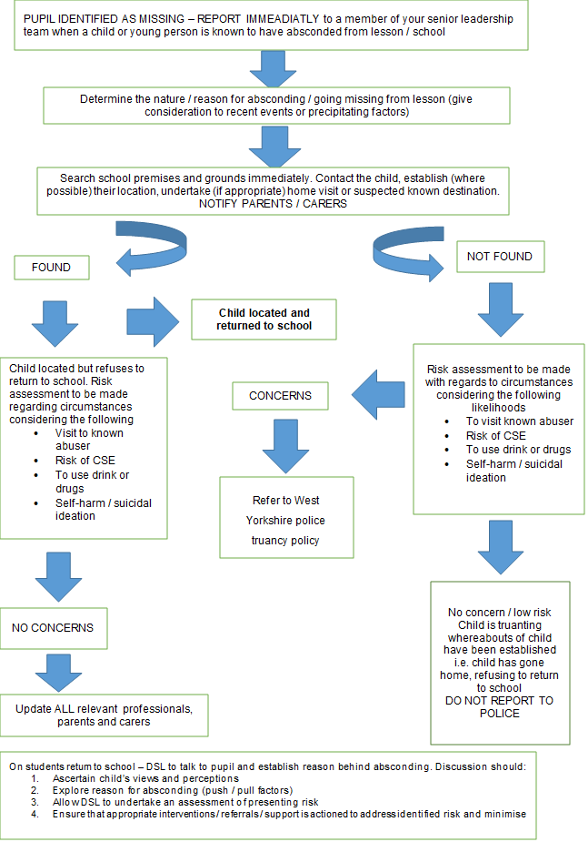

Appendix iii – Support to Self-Regulate Plan

Name: Date:

Prevention Strategies (these go in the green box) | Diversion and Distraction (these go in the amber box)
De-escalation including safe spaces

All staff to use a consistent approach to support x to manage big feelings by using the vital relational functions (VRF’s):
- Attune to his emotional state – “I can see that you are really angry with me”
- Validate his felt experience – “I can imagine how cross you were when you thought that I had taken your picture down”
- Contain his emotions – “I can keep you safe while/until these feelings go away”
- Support him to sooth and calm – “We can make things better, together, when you are ready”

Use a nurturing, non-confrontational approach with firm boundaries

Support x to elicit his thoughts and feelings by ‘wondering aloud’ in a curious way

Support him to develop his empathy by providing an empathic restorative approach to repairing and rebuilding relationships, and providing x and others with an exaggerated sense of empathy.

Support x to understand how his thoughts and feelings are linked to his behaviour and how these affect others by using reflective language, wondering aloud, restorative repair and rebuilding of relationships

Triggers (including different environments) |  | Language scripts  “I can see you are finding this a bit tricky “  “I am wondering if …”  “you will be able to …. when you ….  (validate feelings as above) | Key People
Additional risks if out of school

Risk Assessment  Insert school RA here | Description of Risk |  | Likelihood of it happening (Low, Med, High) |  |  | Adverse outcomes if not managed
Positive Handling Strategies |  | Post incident support (repair and rebuild) |  | Recording and notifications required
Written by and date |  | Reviewed and Updated (date) |  | Signed
 |  |  |  | Staff
 |  |  |  | Parent

Green Strategy
Strengths | Support strategies
Is calm concentrating and relaxed –

describe what the child looks like, behaviours, body language

Amber Strategy
Difficulties | Support strategies
Becomes unsettled – early signs of anxiety

describe what the child looks like, behaviours, body language

Red Strategy
Challenges | Support strategies
describe what the child looks like, behaviours, body language | De - escalation strategies used at all times  All staff to use a consistent approach to support x to manage big feelings by using the vital relational functions (VRF’s):  - Attune to his emotional state – “I can see that you are really angry with me”  - Validate his felt experience – “I can imagine how cross you were when you thought that I had taken your picture down”  - Contain his emotions – “I can keep you safe while/until these feelings go away”  - Support him to sooth and calm – “We can make things better, together, when you are ready”  Use a nurturing, non-confrontational approach with firm boundaries  Support x to elicit his thoughts and feelings by ‘wondering aloud’ in a curious way  Support him to develop his empathy by providing an empathic restorative approach to repairing and rebuilding relationships, and providing x and others with an exaggerated sense of empathy.  Support x to understand how his thoughts and feelings are linked to his behaviour and how these affect others by using reflective language, wondering aloud, restorative repair and rebuilding of relationships

Natural consequences
Adults are in control and stop the unsafe behaviour.
When calm –reflect on thoughts and feelings, using non-confrontational language, offer an appropriate strategy/phrase to say next time. “Next time you feel like this, you need to ………..”
Natural consequences are implemented before an enjoyable time –
  - Follow initial instruction
  - Practice desired behaviour
  - SMART task of work missed
  - Repair and rebuild relationship

Appendix iv - Class Team Debrief

Positives
What factors or approaches contributed to the students' positive behaviour or engagement?
(3 Mins)

Issues
List any challenges and identify who will log it and who will follow it up?
Follow up can include: restorative with the student; informing parent, SLT, Behaviour Support, DSL, form tutor; Logging on Arbor/ CPOMs;
(5 Mins)

Reflection
Reflecting on the challenges listed above, what can be done differently tomorrow?
Is there anything, SLT, Behaviour Support or DSL can support you with?
Is there anything that needs to be shared with staff in the morning briefing?
(5 Mins)

Attendance
Please identify who was absent today, the number of continuous days absence, what follow up steps will be taken and who will carry out the actions.
e.g. Anna, 2 days, Mr. Jones will call home
(3 Mins)

Appendix v - Ethos Academy Trust Behaviour Principles Statement

Ethos Academy Trust’s first priority is the responsibility to safeguard and promote the welfare of all our pupils. As such, the Trust Board is charged with the duty to set the framework of the behaviour/relational policies of each academy by providing a written statement of general principles relating to behaviour and attitude to learning, taking into account the needs of all stakeholders.
Vision
Our vision at Ethos Academy Trust is to create nurturing inclusive learning communities.

Mission
To enable us to achieve this, our mission is that Ethos Academy Trust will draw upon the expertise of our specialist staff and wider partners to provide timely, personalised support, intervention and provision in order to maximise the life chances of all children and young people, informed by a thorough understanding of their strengths and needs.

Core Values
- Leading with Integrity
- Championing honesty and transparency
- Building trusting relationships
- Thinking innovatively
- Finding creative solutions
- Meeting individual need
- Encouraging freedom and responsibility
- Working collaboratively
- Investing in effective partnerships
- Celebrating achievement
- Improving academic progress
- Enriching personal development
- Improving continuously
- Raising Standards
- Developing strong and effective leaders

Our behaviour culture
Our behaviour policy and practices are underpinned by relational practice. Relational practice means that relationships are at the heart of our interactions and interventions. The children in our settings often have attachment challenges linked to trauma and Aces with many also having special educational needs including social, emotional and mental health (SEMH) needs. This means that our children often use behaviour as a form of communication. Our approach is to look beyond the behaviour to understand what is being communicated. We know we need to connect before we can correct.
Behaviour and positive relationships are modelled by all staff; this is a key part of our curriculum and also targeted through personalised interventions.

The Ethos Academy Trust Board believes in high standards of behaviour coupled with high support for pupils which enables

- all pupils to make the best possible progress in all aspects of their educational life;
- all staff to teach, model and promote good learning.
The Trust Board fully supports the rights of all members of our community to work, learn and achieve in a safe, supportive and stimulating environment. All members of our Trust community are fully committed to working together to establish a positive academy ethos and promote effective learning within an environment where all children can feel safe, enjoy and achieve, be healthy, develop resilience and be prepared for the next stage of their educational journey. Behaviour should not jeopardise the health and safety of any member of the school community and all stakeholders are encouraged at all times to be positive role models. Through consistently applying the principles of nurture and trauma informed approaches our pupils are given the strategies to be able to engage fully in learning whilst being supported by staff who are skilled in identifying and addressing all aspects of SEMH.

The right to feel safe at all times

All staff and pupils have the right to:

- feel safe;
- learn;
- be treated with respect;
- work in a positive, welcoming school community;
- be heard.

With rights go responsibilities, which apply to staff and pupils who all have a responsibility to:

- keep the school a safe place to be;
- allow each other to learn;
- feel physically and emotionally safe;
- treat each other with respect and dignity;
- develop and maintain a positive, welcoming school community;
- Co-regulate and communicate needs calmly and safely,
- listen to each other.

Inclusivity

Ethos Academy Trust is an inclusive Trust. All members of the Trust’s community should be able to work and learn, free from any form of discrimination, harassment or bullying (as laid down in the Equality Act, 2010.) Measures to protect pupils from bullying and discrimination as a result of gender, race, ability, sexual orientation or background are clearly set out and regularly monitored for their effective implementation. Reasonable adjustments are made to day-to-day life, policies and procedures in order to meet individual needs.

Engaged Community/Parental Involvement

At Ethos Academy Trust we believe that a positive, supportive relationship between parents/carers/families and professionals and each academy is key to meeting the needs of every child. Regular opportunities to visit school through parent consultation meetings, open days and fundraising events aim to encourage and support parents / carers / families to be actively involved within the academy community.

Parents / carers / families / professionals and pupils will be made aware of the behaviour/relational policy of the academy during the induction process, which may include a ‘Home School Agreement’. Parents/carers/ families are contacted on a regular basis, often daily but at least weekly, to share positive news and discuss any concerns. Involvement with parents/carers/families and professionals will be on an individual basis. Parental preference around home/school contact will be discussed at the initial meeting when a child joins Ethos Academy Trust.

Positive re-enforcement
The emphasis will be on encouraging positive behaviour and school attendance through:
- high expectations coupled with high support;
- the modelling and teaching of good behaviour, developing pupils’ social and emotional skills;
- a focus on learning through an engaging, differentiated curriculum that meets the needs of each learner;
- praise and rewards, catching pupils getting it right.
All members of staff will recognise and celebrate positive behaviour at all times around the academy through informal praise. Children’s best efforts for behaviour and learning will be celebrated regularly and success shared with parents/carers and families. The Trust Board recognise that a wide range of rewards are consistently and fairly applied in such a way as to encourage and reinforce good behaviour in the classroom and elsewhere. These are made clear in the Behaviour/Relational Policy (and / or other policies).
Logical Consequences/ Restorative Culture for unsafe behaviour
Consequences for unsafe behaviour should be known and understood by all staff and pupils and consistently applied. The range of sanctions should be described in the Behaviour/Relational Policy so that pupils, staff, parents and families can understand how and when these are applied. Consequences, when necessary, will enable the pupil to reflect on, and learn from, their behaviour and to make reparation wherever possible. The focus on positive behaviour, forgiveness and reconciliation will significantly reduce the need for exclusion or suspension. However, when considering appropriate next steps, including consequences the Headteacher must balance the needs of the individual with those of the wider school community and where pupil behaviour places others at risk, the safety of the pupil body as a whole is paramount. The Trust strongly believes that suspensions must be used only as a very last resort.
Positive Handling
All our child facing staff across the trust are trained in a positive handling technique called Team Teach. This supports staff with the de-escalation strategies to help regulate pupils. This de-escalation makes up 95% of our work when supporting children that are dysregulated. If a child is posing significant risk of harm to themselves, others, property or whole school disruption then staff may use physical intervention for which they are fully trained. Individual policies will outline the process for Positive Handling, searching, screening and confiscation as outlined in the DFE 2022
Sharing of Information
The Trust Board requires the academies to maintain up to date records of pupils and to ensure that, in relation to their policies on Safeguarding and Child Protection, they are GDPR compliant when sharing information. The Trust takes seriously the responsibility to maintain personal records within suitable, safe and secure systems.

Appendix vi – Classroom Reward Displays

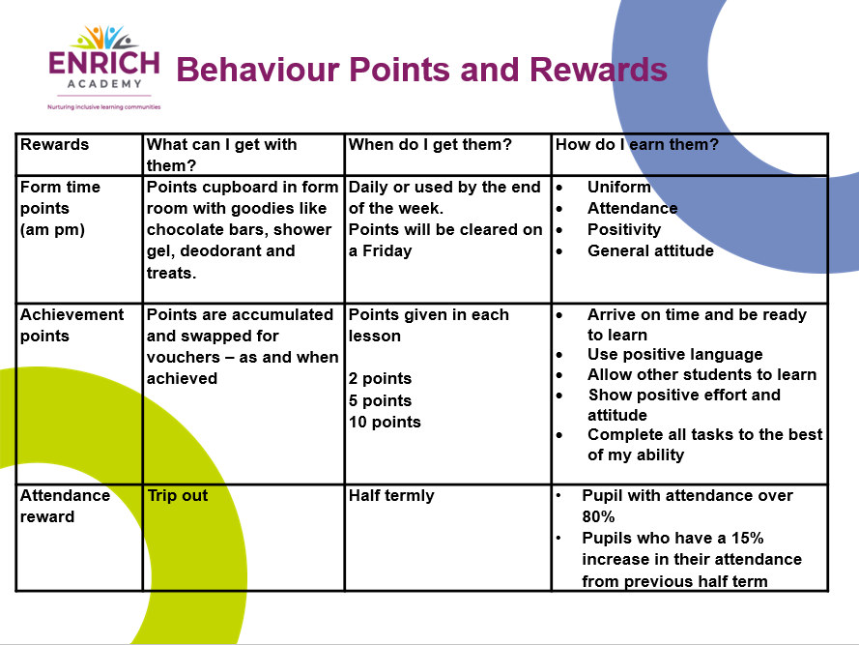

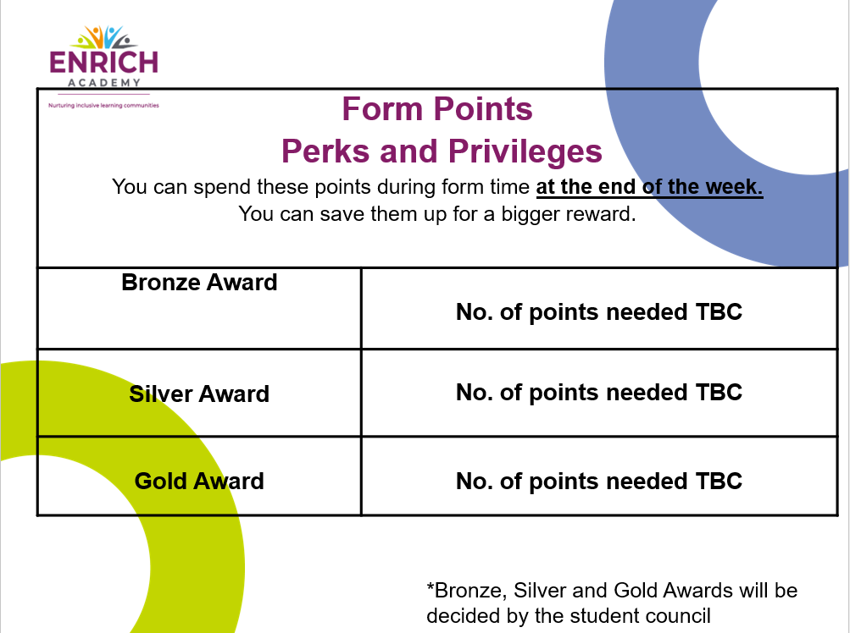

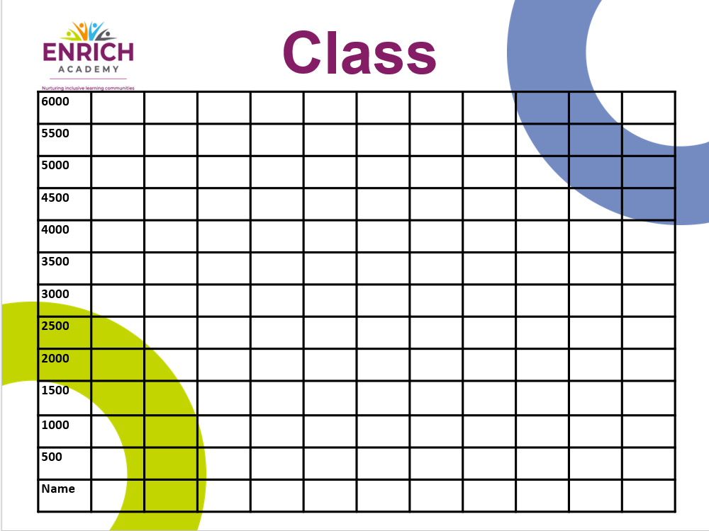

Appendix vii – Reintegration Log
Witness statements submitted | Yes | No
Incident report read | Yes | No
Risk Assessment up to date | Yes | No
On a current PTT | Yes | No
Considerations of SEND | Yes | No
Current EHCP | Yes | No
Outside Agencies involved | Yes | No
If yes for previous question, who

Pupil | Year Group | Key Adults
Meeting Date | Meeting Time | Meeting Location
Days suspended | Total days of suspension | Duel site registered  Yes No

Strategies used previously
Current curriculum offers
e.g., nurture based/academic classroom
New offer/new strategies

Parent Voice
Pupil Voice

Staff informed of any changes | Yes | No | NA
Paper work completed for any changes to TT | Yes | No | NA
New risk assessment in place | Yes | No | NA
Move to alternative timetable/PTT | Yes | No
Outside agencies contacted | Yes | No | NA
If yes for previous question, who

Time and date of restorative session/sessions  Question prompts:  What happened?  What were you thinking and feeling at the time?  What have you thought about or felt since then?  What impact has this incident had on you and others?  What has been the hardest thing for you?  What do you think needs to happen to make things right?  Who can you go to for support?  Completed □ | Names of staff/pupils attending
Review after week 1
Review after week 3
Further notes if required

Appendix viii – Team Teach Information Sheet

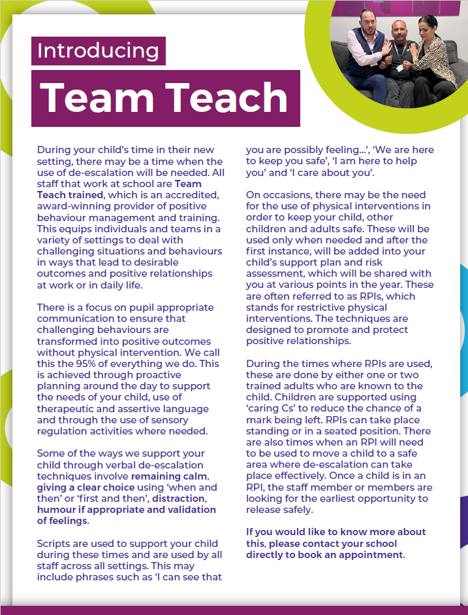

Notes

- This Statement has been drawn up in accordance with the Education and Inspections Act, 2006, and DfE: Behaviour and discipline in schools: Advice for Headteachers and school staff (January 2016).
- The purpose of the Statement is to provide guidance to the Headteachers in drawing up their individual Behaviour/Relational Policies so that they reflect the shared aspirations and beliefs of all stakeholders in Ethos Academy Trust: Trustees, staff, parents / carers/families and pupils, as well as taking full account of law and guidance on behaviour matters. It is intended to help all staff to be aware of and understand the extent of their responsibilities in respect of recognition and reward for good behaviour, discipline and sanctions for unacceptable behaviour and how to use them. Staff should be confident that they will always have the Trustees’ support when following this guidance.
- This is a statement of principles, not practice: it is the responsibility of the Headteacher to draw up the academy’s behaviour policy, though the Headteacher must take account of these principles when formulating this policy. The Headteacher should also take account of the guidance in DfE: Behaviour and Discipline in Schools Advice for Headteachers and School Staff (January 2016).
- With consideration of our duty of care to the pupils, this written statement and the policies that are influenced by it apply to all pupils when in school, when travelling to and from school, when engaged in extra-curricular activities such as educational trips and visits (residential and non-residential) and when being educated as a member of the Ethos Academy Trust community off-site.
- Each academy’s Behaviour/Relational Policy is to be published on the academy’s website and distributed to all members of staff.

