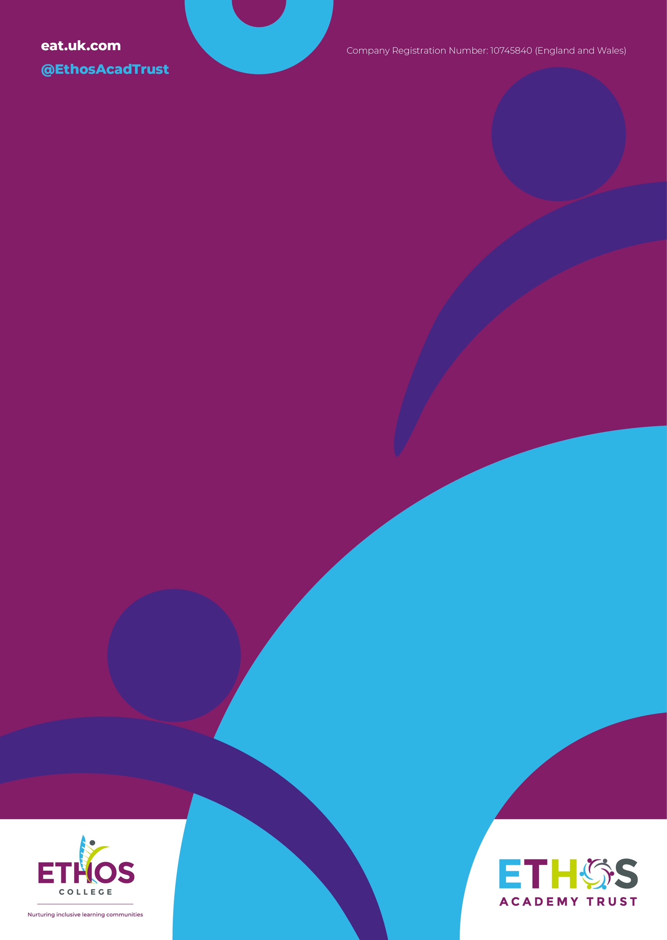

Enrich Academy

RSE Policy

October 2023

 | Summary | RSE Policy
 | Responsible person | Claire Sansom
 | Accountable ELT member | Emma McManus
 | Applies to | Enrich Academy
 | Trustees and/or individuals who have overseen development of this policy | N/A
 | Headteachers/Service Heads who were consulted and have given approval (if applicable) | Emma Mcmanus
 | Ratifying committee(s) and date of final approval | Learning and Achievement Committee
 | Available on:  Every  Trust Website  Academy Website  Staff Portal | Y/N  Y/N  Y/N  Y/N
 | Related documents (if applicable) | N/A
 | Disseminated to All Enrich Academy Staff | N/A
 | Date of implementation (when shared) | September 2023
 | Date of next formal review | September 2024
 | Consulted with Recognised Trade Unions | N/A
 | Adopted by Ethos Academy Trust following consultation | N/A

Section | Description
1. | Introduction
2. | Aims
3. | Legislation and Statutory Guidance
4. | Definition
5. | Policy Development
6. | Roles and Responsibilities
7. | Delivery of RSE Curriculum
8. | Monitoring of Quality of Provision for RSE
9. | Policy Review
 | Appendices
A | By the end of Secondary school pupils should know
B | Sample letter for parents/carers (withdraw)

- Introduction
Enrich Academy considers that Relationships, Sex and Education (RSE) is an integral part of the Personal, Social, Health and Economic Education (PSHE) and is embedded throughout the curriculum (eg. science, PE, topic based learning) and throughout the school day. We aim to offer students a carefully planned programme on human development, relationships, sexuality and family life within a safe, comfortable atmosphere and in a relaxed relationship between teacher and pupil. The programme is set within a moral framework and matched to the pupils’ level of maturity.

- Aims
The aims of relationships and sex education (RSE) within our provision are to:
• Provide a framework in which sensitive discussions can take place
• Give an understanding of sexual development and the importance of health and hygiene
• Help pupils develop feelings of self-respect, confidence and empathy to value themselves and others
• Create a positive culture around issues of sexuality and relationships
• Teach pupils the correct vocabulary to describe themselves and their bodies

- Legislation and Statutory Guidance
At Enrich Academy, we teach RSE as set out in this policy. As a secondary school, Enrich Academy must provide RSE to all pupils under section 34 of the Children and Social Work Act 2017. The policy is informed by Relationships Education, Relationships and Sex education (RSE) and Health Education statutory guidance (DfE,2019)
In teaching RSE, we’re required by our funding agreements to have regard to guidance issued by the secretary of state, as outlined in section 403 of the Education Act 1996.
We also have regard to legal duties set out in:
• Sections 406 and 407 of the Education Act 1996
• Part 6, chapter 1 of the Equality Act 2010
• The Public Sector Equality Duty (as set out in section 149 of the Equality Act 2010). This duty requires public bodies to have due regard to the need to eliminate discrimination, advance equality of opportunity and foster good relations between different people when carrying out their activities.

- Definition
RSE is about the emotional, social, cultural development and physical aspects of growing up, and involves learning about relationships, sexual health, sexuality, healthy lifestyles, diversity and personal identify. Some aspects are taught in science, and others are taught as part of personal, social, health and economic education. It also gives pupils and young people essential skills for building positive, enjoyable, respectful and non-exploitative relationships, sharing information and exploring issues and values and staying safe both on and offline (21st Century Guidance 2014).

- Policy development
In developing our policy and curriculum, we have given due regard to the Government’s statutory guidance for RSE. The views of the whole school community have been considered when developing the policy and content of RSE and involved the following steps:
1. Review – a member of staff reviewed current practice and pulled together all relevant information including national and local guidance
2. Inform - DfE guidance and information about RSE was shared with stakeholders (children, staff, parents, and trustees).
3. Staff Consultation – all school staff were given the opportunity to look at the policy and make recommendations
4. Parent/Trustee consultation – parents and any interested parties were invited to contribute to the policy and practice
5. Pupil consultation – we investigated what exactly pupils want from their RSE
6. Approval – once amendments were made, the policy was shared with Trustees and approved
7. Support – the final policy, curriculum and resources were shared with all stakeholder and added to the school website. This will help parents complement the teaching in school

6. Roles and responsibilities
6.1 The Board of Trustees
The Learning and Achievement Committee will represent the Board of Trustees in approving the RSE policy, and hold the CEO and Head Teachers to account for the implementation of this policy.
6 6.2 The Head Teacher
The Head Teacher is responsible for ensuring that RSE is taught consistently across the school, that parents and staff are informed about our RSE policy, that members of staff are given sufficient training, so that they can teach effectively and handle any difficult issues with sensitivity, monitor this policy on a regular basis and report to trustees on the effectiveness and for managing requests to withdraw pupils from non-statutory components of RSE.
6.3 Staff
Staff are trained on the delivery of RSE as part of continuing professional development and are responsible for:
• Delivering RSE in a sensitive way
• Modelling positive attitudes to RSE
• Monitoring progress
• Responding to the needs of individual pupils
• Responding appropriately to pupils whose parents wish them to be withdrawn from the [non-statutory] components of RSE Staff do not have the right to opt out of teaching RSE. Staff who have concerns about teaching RSE are encouraged to discuss this with the headteacher.
6.4 Pupils
Pupils are expected to engage fully in RSE and, when discussing issues related to RSE, treat others with respect and sensitivity.
6.5 Parents
Parents have the right to withdraw their children from the [non-statutory] components of sex education within RSE up to and until 3 terms before the child turns 16. After this point, if the child wishes to receive sex education rather than being withdrawn, the school will arrange this. Requests for withdrawal should be put in writing using the form found in Appendix B of this policy and addressed to the headteacher. A copy of withdrawal requests will be placed in the pupil’s educational record. The headteacher will discuss the request with parents and take appropriate action. Alternative school work will be given to pupils who are withdrawn from sex education.

- Delivery of RSHE Curriculum
RSE is not delivered in isolation; it is embedded throughout the school’s curriculum, both in academic lessons and wider aspects of school life. The programme of study builds on an individual’s knowledge, skills and experiences, demonstrating inclusion throughout, using a blend of teaching methods, opportunities to practice skills and become familiar with situations. The school’s curriculum is designed to ensure that students have acquired the knowledge and skills set out in appendix A.
The broader personal, social, health and economic (PSHE) programme includes economic well-being, careers and enterprise education. Relationships education focuses on teaching the fundamental building blocks and characteristics of positive relationships including:
• Families and people who care for me
• Caring friendships
• Respectful relationships
• Online relationships
• Being safe
• Intimate and sexual relationships, including sexual health (KS3/4) These areas of learning are taught within the context of family life taking care to ensure that there is no stigmatisation of children based on their home circumstances (families can include single parent families, LGBTQ+ parents, families headed by grandparents, adoptive parents, foster parents/carers amongst other structures) along with reflecting sensitively that some children may have a different structure of support around them (for example: looked after children or young carers).
We will also be mindful of the law and legal requirements, taking care not to condone or encourage illegal political activity, such as violent action against people, criminal damage to property, hate crime, terrorism or the illegal use of drugs. For more information about our RSE curriculum, see please visit the academies website or contact them for further information.
7.1 Inclusivity
We will teach about these topics in a manner that:
• Considers how a diverse range of pupils will relate to them
• Is sensitive to all pupils’ experiences
• During lessons, makes pupils feel safe, supported and able to engage with the key messages.
We will also:
• Make sure that pupils learn about these topics in an environment that’s appropriate for them, for example in a whole-class setting, small groups or targeted sessions and 1-to-1 discussions.
• Give careful consideration to the level of differentiation needed
  - Use of resources
We will consider whether any resources we plan to use are aligned with the teaching requirements set out in the statutory RSE guidance, are age-appropriate, given the age, developmental stage and background of our pupils, are evidence-based and contain robust facts and statistics, fit into our curriculum plan, are from credible sources, are compatible with effective teaching approaches and are sensitive to pupils’ experiences and won’t provoke distress.

- Monitoring the Quality of Provision for RSE
A designated member of staff in each academy will report to the Headteacher and the RSE link trustee to discuss the quality of provision and effectiveness of RSE curriculum. The quality of teaching and learning of RSE is monitored by Senior Leaders through planning scrutiny, learning walks, pupil discussions and examples of work. This policy and scheme of work will be regularly reviewed annually by the Personal Development lead and Senior Leadership Team at Enrich Academy and any feedback from teachers, parents/carers and pupils will be considered.

9. Policy Review
This policy and scheme of work will be regularly reviewed annually by the Personal Development lead and Senior Leadership Team at Enrich Academy.
Changes will be communicated to all staff and parents and will be approved by the Board of Trustees. The review should consider any changes to statutory guidance; feedback from pupils, parents or staff; and the school context.

Appendix A: By the end of secondary school pupils should know:
Families
• That there are different types of committed, stable relationships
• How these relationships might contribute to human happiness and their importance for bringing up children
• What marriage is, including their legal status, e.g. that marriage carries legal rights and protections not available to couples who are cohabiting or who have married, for example, in an unregistered religious ceremony
• Why marriage is an important relationship choice for many couples and why it must be freely entered into
• The characteristics and legal status of other types of long-term relationships • The roles and responsibilities of parents with respect to raising of children, including the characteristics of successful parenting
• How to: determine whether other children, adults or sources of information are trustworthy: judge when a family, friend, intimate or other relationship is unsafe (and to recognise this in others’ relationships); and, how to seek help or advice, including reporting concerns about others, if needed
Respectful relationships, including friendships
• The characteristics of positive and healthy friendships (in all contexts, including online) including: trust, respect, honesty, kindness, generosity, boundaries, privacy, consent and the management of conflict, reconciliation and ending relationships. This includes different (non-sexual) types of relationship
• Practical steps they can take in a range of different contexts to improve or support respectful relationships
• How stereotypes, in particular stereotypes based on sex, gender, race, religion, sexual orientation or disability, can cause damage (e.g. how they might normalise non-consensual behaviour or encourage prejudice)
• That in school and in wider society they can expect to be treated with respect by others, and that in turn they should show due respect to others, including people in positions of authority and due tolerance of other people’s beliefs
• About different types of bullying (including cyberbullying), the impact of bullying, responsibilities of bystanders to report bullying and how and where to get help
• That some types of behaviour within relationships are criminal, including violent behaviour and coercive control
• What constitutes sexual harassment and sexual violence and why these are always unacceptable
• The legal rights and responsibilities regarding equality (particularly with reference to the protected characteristics as defined in the Equality Act 2010) and that everyone is unique and equal
Online and media
• Their rights, responsibilities and opportunities online, including that the same expectations of behaviour apply in all contexts, including online
• About online risks, including that any material someone provides to another has the potential to be shared online and the difficulty of removing potentially compromising material placed online
• Not to provide material to others that they would not want shared further and not to share personal material which is sent to them
• What to do and where to get support to report material or manage issues online
• The impact of viewing harmful content
• That specifically sexually explicit material e.g. pornography presents a distorted picture of sexual behaviours, can damage the way people see themselves in relation to others and negatively affect how they behave towards sexual partners
• That sharing and viewing indecent images of children (including those created by children) is a criminal offence which carries severe penalties including jail
• How information and data is generated, collected, shared and used online
Being safe
• The concepts of, and laws relating to, sexual consent, sexual exploitation, abuse, grooming, coercion, harassment, rape, domestic abuse, forced marriage, honour-based violence and FGM, and how these can affect current and future relationships
• How people can actively communicate and recognise consent from others, including sexual consent, and how and when consent can be withdrawn (in all contexts, including online)
Intimate and sexual relationships, including sexual health
• How to recognise the characteristics and positive aspects of healthy one to-one intimate relationships, which include mutual respect, consent, loyalty, trust, shared interests and outlook, sex and friendship
• That all aspects of health can be affected by choices they make in sex and relationships, positively or negatively, e.g. physical, emotional, mental, sexual and reproductive health and wellbeing
• The facts about reproductive health, including fertility and the potential impact of lifestyle on fertility for men and women
• That there are a range of strategies for identifying and managing sexual pressure, including understanding peer pressure, resisting pressure and not pressurising others
• That they have a choice to delay sex or to enjoy intimacy without sex
• The facts about the full range of contraceptive choices, efficacy and options available
• The facts around pregnancy including miscarriage
• That there are choices in relation to pregnancy (with medically and legally accurate, impartial information on all options, including keeping the baby, adoption, abortion and where to get further help)
• How the different sexually transmitted infections (STIs), including HIV/AIDs, are transmitted, how risk can be reduced through safer sex (including through condom use) and the importance of and facts about testing
• About the prevalence of some STIs, the impact they can have on those who contract them and key facts about treatment
• How the use of alcohol and drugs can lead to risky sexual behaviour
• How to get further advice, including how and where to access confidential sexual and reproductive health advice and treatment

Appendix B: Parent form: withdrawal from sex education within RSE Parental withdrawal from sex education delivered as part of the RSE/PSHE ed curriculum
The parent(s) and the Headteacher will complete the form: This will record the main points of the discussion (if this has taken place), the reason for the withdrawal, and the arrangements for ensuring the pupil receives appropriate, purposeful education during the period of withdrawal. This will be reviewed at least annually.

Parental withdrawal from sex education delivered as part of the RSHE/PSHE ed curriculum
A copy of this form should be given to the parent(s) and a copy retained in school

Name of child
Name of parent(s)
Year group/class
Reason for withdrawing the child from sex education delivered as part of RSHE/PSHE education
Any other information you wish the school to consider
Parent(s) signature

To be completed by the Headteacher:
Notes from discussion with parent(s)
How the school will inform the parent about sex education
Where the pupil will work/supervision
Work to be undertaken by the pupil at this time
Headteacher signature
Review date

livered as part of the RSHE/PSHE ed curriculum A copy of this form should be given to the parent(s) and a copy retained in school to be completed by the parent(s)

