Enrich Academy

Attendance Policy
October 2023

Date | Version | Action | Summary of changes
July 23 | 1.4 |  | Reviewed to include increased support, identify barriers to attendance and develop interaction and dialogue around attendance between form tutors, students and their parents/ carers.

Contents
Section | Description | Page
1. Introduction …………………………………………………………………..3
2. School Attendance………………………………………………………….. 3
3. National, Local and Parental Responsibilities for School Attendance4
4. Roles and Responsibilities…………………………………………………5
4.1 School Responsibilities ………………………………………………………………5
4.2 Responsibilities of Parents…………………….………………………………………8
4.3 Responsibility of Students…………………………………………………………….8
4.4 Responsibilities of the Local Authority………………………………………………9
5. The Importance of Good Attendance……………………………………9
6. Persistent Absence (PA)…………………………………………………..9
7. Attendance Improvement Strategy………………………………………9
7.1 Procedures to Improve Attendance………………………………………………...10
7.2 Attendance Monitoring Programme…………………………………………………10
8. Interventions to Support Attendance……………………………………11
8.1 Emotional Based School Avoidance (EBSA)……………………………………….11
8.2 Personalised Timetables ……………………………………………………………..11
8.3 Outreach………………………………………………………………………………..12
8.4 External Support……………………………………………………………………….12
9. Transition Timetables………………………………………………………13
10. Children missing in education (CME)…………………………………13
10.1 Action the Centre Will Take Regarding CME……………………………………….13
11. Attendance Rewards……………………………………………………..14

Appendices

Appendix | Description | Page
Appendix 1 – Daily Arrival and Registration Procedure 14
Appendix 2 – Absence Response flowchart for Enrich Academy 16
Appendix 3 - Attendance Rewards 18
Appendix 4 – Attendance Improvement Plan 19
Appendix 5 – Part Timetable Arrangement…………………………………………………………………..20
Appendix 6. Attendance Codes and when to use them 22

Attendance Policy

Introduction
At Enrich Academy, we have established this policy to outline our procedures aimed at enhancing school attendance, promoting punctuality, and ultimately elevating levels of achievement. We firmly believe that attendance serves as a protective factor, enabling us to identify students' needs at an early stage and provide them with the necessary support.

This policy is developed with diligent regard for the legal powers and duties and guidance from the Department for Education outlined in the following documents:
- The Education Act 1996 - sections 434(1)(3)(4)&(6) and 458(4)&(5);
- The Education Act 2002, Section 175
- The Education (Student Registration) (England) Regulations 2006;
- The Registration (Pupil Registration) Regulations 2006
- The Education (Student Registration) (England) (Amendment) Regulations 2010; and
- The Education (Student Registration) (England) (Amendment) Regulations 2011
- Working together to improve school attendance DfE Guidance
- School attendance and absence - childlawadvice.org.uk

School Attendance

At Enrich Academy, we understand the unique challenges faced by students due to social, emotional, and mental health (SEMH) difficulties. We recognise the crucial role that consistent school attendance plays in supporting their overall well-being and educational progress. Regular attendance at Enrich Academy helps foster positive relationships, improves social and emotional development, and provides a supportive environment to enhance educational outcomes. We believe all students deserve this opportunity in order to thrive academically and personally.

As students have specific needs, regular attendance is highly valued and encouraged. We are aware that there may be circumstances that make it difficult to attend school consistently, and we are committed to working with students and their parents/carers to address any attendance issues. We understand that student well-being and individual circumstances may impact on the students’ ability to attend, and we encourage open communication between students, parents/carers, and our staff to ensure we provide the necessary support.
Drawing from guidance provided by the Department for Education (DfE) on Working Together to Improve School Attendance, we acknowledge that some students may face greater obstacles to attending school regularly. Therefore, at every stage of our efforts to improve attendance, we work closely with students, their families and local partners to identify and remove barriers to attendance. This involves fostering strong and trusting relationships and working collaboratively to implement tailored support measures.

We firmly believe that achieving good attendance cannot be pursued in isolation. Effective strategies for improvement necessitate close alignment with various aspects of school life, including curriculum delivery, behaviour management, bullying prevention, support for special educational needs and mental health and well-being initiatives. We recognise that improving attendance requires a collective effort, and concerted endeavour involving all teaching and non-teaching staff in the school, the Senior Leadership Team, the Trust, the Local Authority, and other local partners.
Our policies and procedures are developed in line with the recognition of the unique challenges that students with SEMH difficulties may experience. We are committed to working together with all stakeholders to create an inclusive and nurturing environment where students can thrive academically and personally. Together, we aim to overcome any barriers to attendance and ensure that all students have every opportunity to succeed academically, develop positive relationships, and enjoy their school experience. We do this by:
- Creating a warm and welcoming environment based upon the principles of nurture
- Ensuring that students feel safe
- Supporting positive relationships with staff and peers
- Making education enjoyable, interesting and appropriate to every child’s needs.
- Encouraging, praising and rewarding success

National, Local and Parental Responsibilities for School Attendance
Both the DfE and OFSTED place significant emphasis on addressing persistent absence, recognising its direct impact on academic achievement, the risk of 'not in employment, education, or training' (NEET) status, poor mental health, increased likelihood of involvement in criminal activity, and poorer health outcomes. These factors have been exacerbated by the pandemic. The shared commitment outlined in the DfE Guidance ‘Working Together to Improve School Attendance’ articulates a vision for effective school-level policies and practices, emphasising collaboration with Local Authorities and relevant partners.

Wakefield Local Authority aligns with this commitment to enhance school attendance and has collaborated with children, young people, families, and various stakeholders including the Education Welfare Service, Alternative Provision Team, SENART, Educational Psychology, Children’s Social Care, Heads, Senior Leaders, West Yorkshire Police, and other local partners to develop an attendance strategy for all schools and academies in Wakefield.

At Enrich Academy, we wholeheartedly embrace this commitment to collaborate with the Local Authority and external partners to enhance school attendance. All members of our community - staff, students, parents/carers - share the responsibility to achieve this objective. It's imperative to recognise that parents are legally obligated to ensure their children receive a suitable full-time education, tailored to their specific needs. In cases where attendance concerns persist despite exhaustive support efforts, we will seek assistance from the Local Authority and external agencies, exploring alternative strategies to support attendance and educational progress.

Every child of compulsory school age is entitled to a suitable and full-time education that accommodates their age, abilities, and any special educational needs. Parents bear the legal responsibility to ensure their child receives this education, through regular school attendance. In some cases, parents may opt for Elective Home Education (EHE).

Upon enrolling their child at Enrich Academy, parents assume an additional legal duty to ensure regular school attendance, with exceptions such as illness or pre-approved absences. Should parents opt for EHE, we offer advice and guidance to ensure a thorough understanding of the process and requirements. The Attendance and Enrolment Officer will liaise with parents and the Education Welfare Service to provide appropriate support and guidance for those considering EHE.

Parents will be informed of the requirement to notify the Local Authority and will receive assistance in completing the necessary documentation and forms for EHE. The child will remain enrolled at Enrich Academy until all requirements are met, and the parent formally notifies the Head Teacher of their intent for EHE in writing. Upon receipt of such notification, the information will be shared with the Local Authority.

Roles and Responsibilities

We recognise that promoting good attendance cannot be viewed in isolation. Effective strategies to enhance attendance encompass various areas, including curriculum design, behaviour management, anti-bullying initiatives, support for special educational needs, pastoral care, mental health and well-being, and efficient allocation of resources.

Achieving optimal attendance is not solely the responsibility of one staff member; it requires a collective endeavour involving parents/ carers all teaching and non-teaching staff and other community partners. We acknowledge that the barriers to accessing education are multifaceted and vary for each student and family. By working collaboratively with students and parents, we aim to establish strong relationships based on trust, which can be helpful when addressing any obstacles to attendance by implementing suitable support measures. This endeavour is underpinned by Wakefield’s School Attendance Strategy. A Quick guide for parents, carers, schools, governors and trusts can be found here. This document outlines the LA’s approach to improve school attendance and is designed to be graduated, responsive and partnership based, to consider the nuances in the barriers to school attendance.

School Responsibilities
At Enrich Academy we maintain accurate records of student attendance, documenting students' presence or absence during both morning and afternoon sessions. In instances of student absence, parents/ carers are required to promptly notify the school, providing a reason for their non-attendance.
The school will record the absence under a particular category pre-set by the DfE (See Appendix 7).
In line with the directives set by Wakefield LA, Enrich Academy actively participates in collaborative attendance data-sharing. The aggregated absence data is scrutinised against national and local benchmarks, and comparative data analysis is used to identify areas of commendation and potential improvement. All data collected and shared is in line with GDPR policy.
The Structure of the School Day:
- School opens at 8:30, from 9 – 9:30 students are provided with a healthy breakfast;
- The school day starts at 9am and finishes at 14:00;
- Morning registration is between 9 – 9:30, registers will be closed at 9:30;
- Pupils are registered on Arbor by Form Tutors when they arrive to class;
  - Strategies have been implemented to ensure all staff are aware when students have arrived on site and students are escorted to their form room and between lessons by Teaching Assistants and/ or the Behaviour Support Team
  - Relevant follow up actions are implemented if a student has arrived on site, but does not arrive to their timetabled lesson
- After each transition to a new teacher throughout the day, students will be escorted to class by a TA
- Afternoon registration is between 12:50 – 13:00, registers will close at 13:00.
- Pupils are registered in their afternoon lesson by class teachers.

Every member of staff has a responsibility to promote and support attendance. If students arrive late to registration, they will be given the L code. Where students arrive after registration closes, they will be given the U code.
The Senior Leadership Team will:
- Identify a member of the SLT (Lorna Wright, Assistant Head Teacher, lwright@eat.uk.com ) who will be responsible for attendance in line with ‘Working Together to Improve School Attendance’;
- Support other staff in monitoring the attendance of individual pupils utilising systems that are accessible and ensure positive outcomes;
- Continually monitor the whole school and individual attendance data and implement actions and interventions to address concerns;
- Continually monitor and implement policies and strategies that support consistent school attendance;
- Regularly produce data to analyse attendance information and ensure procedures are in place to address issues;
- Implement a robust line management system that ensures all concerns are identified and addressed in a timely manner;
- Report attendance to students and parents/carers regularly;
- Implement reward systems that motivate students to attend well;
- Support teaching staff to plan a balanced and engaging curriculum that meets individual need and enables change, where necessary, through a strong focus on relationships and personal motivation;
- Embed positive working relationships with partner agencies and ensure that communication is timely and effective;
- Plan a programme of celebration events where pupils’ achievements are recognised and parents/carers and wider stakeholders are included;
- Give attendance a high profile throughout the school;
- Ensure registers are accurately marked and absences are appropriately coded.
- Report regularly to the Board of Trustees.
Responsibilities of the Attendance and Enrolment Officer:
- Monitor attendance data and share with other school staff and external stakeholders such as social care, EWO and Virtual Head, where appropriate;
- Monitor continual absence data and arrange safe and welfare checks after 3 continual days absence;
- Share attendance data with Form Tutors, SLT and DSL Teams;
- Analyse data in relation to a range of demographics to target attendance improvement student cohorts who need it most;
- Monitor Attendance Improvement Plans and Part Timetable Arrangements to reduce persistent and severe absence, and liaise with Form Tutors, DSL Team, EWO and wider support services to remove the barriers to attendance;
- Meet with the Local Authority Education Welfare Officer regularly;
- Take advise from EWO for appropriate actions to promote overall good attendance;
- Share information with EWO to assist their communication with parents/ carers when Local Authority action is required;
- Co-ordinate arrangements for meet with EWO and parents/ carers to discuss their child’s irregular attendance particularly those that are severely absent;
- Liaise the EWO to ensure appropriate action is taken by all professionals involved with the family to promote positive school attendance;
- Make formal referrals to EWO, where necessary to ensure Warnings can be issued to parents/ carers in a timely manner.
Responsibilities of all staff:
- Work to provide an environment that is welcoming and promotes good attendance;
- Ensure relationships with students are positive and individual needs are identified and addressed;
- Work with parents/carers to build positive, transparent relationships;
- Contact parents/carers regularly in the case of any absence and to recognise sustained and improved attendance;
- Ensure attendance is recorded including reasons behind any absences;
- Work with the data to address any reoccurring issues or patterns (such as the same day absence every week);
- Liaise with colleagues and be aware of any related issues;
- Promote a culture of mutual respect and ensure students are valued every day;
- Work closely with colleagues to communicate any issues that may impact attendance;
- Meet regularly with parents/carers and related professionals to address any issues affecting attendance;
- Where necessary, ensure Attendance Support Plans and Part Timetable arrangements are in place and clearly document the roles and responsibilities of school/parent/carer and other professionals (including the mainstream school);
- Reward good and improved attendance in a fair and equitable way ensuring parents / carers are informed.
Staff responsibilities if a pupil does not attend:

- In case of absence, parents are expected to contact us. If they don’t a staff member from the admin team will contact parents/carers via text message. In addition, a staff member will also make contact to identify barriers/ reasons for non-attendance and provide additional support to encourage attendance. This communication will be logged on Arbor. In cases where it has not been possible to make contact with the parent, the Absence Response Flowchart in Appendix 2 will be followed and where necessary, information will be shared with Attendance and Enrolment Officer and/ or DSL Team for further follow up.
- On the third day of absence, if the student has not been seen, it is identified on the Continuous absence report and/ or by staff members liaising with the Attendance and Enrolment Officer, and a safe and welfare check is conducted by the DSL Team or Outreach Team. All home visits and identified concerns will be logged on CPOMs. If there are sufficient concerns and a student is not seen or a parent/carer cannot confirm their whereabouts a 101 call will be made to inform the police.
- A staff member will contact parents/carers at the end of the first day of absence during class debrief time to ensure that any underlying issues regarding attendance are addressed in a timely manner. Working together with parents/carers is essential to ensure good attendance and only when this working relationship is effective can we manage any issues;
- If the absence continues, this will trigger the start of the Attendance Monitoring Program (See 7.2). Where necessary, the DSL will refer the student to external services whilst continuing to monitor and make daily contact with parents. A log of all follow up actions will be documented on CPOMs. The student’s provision may also be reviewed at this time and discussed at a weekly provision meeting.

Ongoing concerns about attendance
If there are ongoing concerns because a student is not attending on a regular basis, support is provided through the Attendance Monitoring Programme (Section 7.2). An Attendance Improvement Plan is Developed reviewed and monitored. The plan may include a change in the student’s educational offer as a short-term measure to support ways to identify and address underlying reasons that may be contributing to non-attendance.

Responsibilities of Parents
- Inform school of any circumstances that may impact on attendance;
- Contact school each day your child is absent;
- Attend regular review meetings and meet with staff on request where there are attendance concerns;
- Arrange holidays out of term time;
- Actively promote good attendance by encouraging and supporting your child to attend;
- Communicate regularly with your child’s form tutor, informing them of any change in circumstance that may affect your child’s attendance. Parent can also contact the DSL Team or SLT if they have serious concerns about their child’s attendance that they would like to discuss further;
- Make medical or other appointments out of school time unless unavoidable;
- Seek permission from the Head Teacher for absences to be authorised. In some cases, students may be authorised to be absent from school at the discretion of the Head Teacher. This may include:
  - The student participating in public performances, including theatre, film or television work and modelling; The student participating in a sporting event; Children from Gypsy, Roma, Traveller and Fairground and Circus Families that have left the area for work purposes;
- Work with staff to implement agreed strategies and actively promote good attendance.

Responsibility of Students
To promote good attendance students will:
- Attend school punctually and regularly
- Follow the expectations of the trust
- Hand in any letters of absence or requests for known absence to their class teacher (including pre-arranged medical appointments)
- Not take holidays in school time

Responsibilities of the Local Authority

Wakefield Local LA attendance strategy outlines clear responsibilities for the LA in promoting good school attendance, enhancing achievement, fostering social well-being, and facilitating positive long-term outcomes for students. Committed to these objectives, we are dedicated to implementing proactive measures aimed at effectively addressing attendance challenges. Our approach is firmly rooted in the collaborative ethos articulated within the Local Authority's attendance strategy, placing emphasis on close cooperation with pertinent partners and stakeholders. In our endeavour, we aim to cultivate a supportive and nurturing environment that fosters positive attendance behaviours and contributes to the holistic development of our students.

The Importance of Good Attendance

Wakefield LA places a strong emphasis on recognising and celebrating good attendance at Enrich Academy. We firmly believe that regular school attendance is crucial for academic progress, social integration, and personal development. We acknowledge that some students may encounter difficulties that affect their attendance, and we are committed to providing the necessary support to help them overcome these challenges.
To encourage and reward positive attendance, we have established a system that acknowledges and celebrates students who demonstrate consistent effort and improvement. Students who maintain an attendance rate higher than 80% or who have shown a significant increase of at least 15% in their attendance since the previous half-term will be rewarded to reinforce the importance of regular attendance and the positive impact it has on their educational journey.
By setting high expectations for attendance and providing targeted recognition, we aim to foster a positive culture where attendance is valued, and students are motivated to engage actively in their education.
We provide a healthy breakfast at Enrich as we know that this starts the day positively and students can then focus and learn. If the student is late, then an important part of the day is missed. Therefore, we also have high expectations for punctuality and where possible provide support with transport to ensure students arrive on time.
We aim to ensure that all students recognise the importance of good attendance and punctuality for the next stage of their education or training as it is a vital life skill.

Persistent Absence (PA)
The Government identifies persistent absence as any student who has attendance of less than 90%. Enrich Academy recognises this figure and aspires to set this standard for all students. However, personalised attendance targets are adjusted dependent on the needs of the individual student. Enrich Academy continually strives to put measures into place to secure and sustain improved attendance.

Attendance Improvement Strategy
If a student’s attendance falls below an acceptable level, we have a variety of strategies to re-engage students and overcome barriers to attendance. Some examples of these are:
- Daily first response text message service
- First day calls
- Strategy meetings
- Liaising with other agencies
- Bespoke/ transition timetables
- Home visits
- Support from EWS
- Rewards for good attendance or an attendance increase of 15% or more since the previous term
- Motivational interventions

Procedures to Improve Attendance
At Enrich, we implement a four-stage programme to encourage and promote good attendance and punctuality. This programme has been developed in line with Wakefield Attendance Strategy: Universal Attendance Procedure Flow chart (Appendix 6). We also provide support to parents to ensure their child’s attendance is exemplary.

Attendance Monitoring Programme

Stage 1 - Informal monitoring; Absence Response

Staff will follow the Absence Response flowchart (Appendix 2);
- Form tutor to make phone calls home to ascertain reasons for absence and identify barriers that can be easily removed.
- Staff member to discuss and agreed upon ways forward to improve attendance.
- Refer to DSL team if appropriate
If further interventions are required because there has been no improvement in attendance:
Stage 2 - Meeting 1– Form tutor to meet with parents/ carers and student
- This meeting will require parents/carers and the student to meet with the form teacher who will set targets and agree a plan to improve attendance.
- Form tutor will make a referral through Provision Map, where necessary
- The Attendance Improvement Plan (See Appendix 4) will be put into action and monitored.
- This will be reviewed after an agreed period of time and successful outcomes will be measured and recorded. The form tutor will remain in contact with the student and their parent/ carer for the duration of the agreed time period.
If further interventions are required because there has been no improvement in attendance:
Stage 3 - Meeting 2 – Member of DSL team to meet with parents/ carer and student
- This will require parents/carers and the student to meet with the member of DSL team
- Where necessary, a referral will be completed on Provision Map to access additional support and/ or change of educational offer to support an increase in their attendance
- Discussions and actions from the Provisions meeting, which is attended by SLT, DSL, Behaviour Intervention Lead and SENCO, will be formulated into an Attendance Improvement Plan by the DSL
  - This may include making referrals to external agencies, Team Around the School, implementing internal interventions, developing a personalised timetable and/ or considering a period of education delivered by on outreach. Dependant on the nature of the non-attendance a risk assessment or liaison with the SENCO to identify unmet needs may also be required to identify strategies to feed into the Attendance Improvement Plan,
- Form tutors will access Provision Map for updates of these discussions following the Provisions meeting. The DSL will share the Attendance Improvement Plan with the form tutor. The Form Tutor will also remain in contact with the student and their parent/ carer through weekly welfare check ins
- The attendance improvement plan will be put into action and monitored by the DSL
- This will be reviewed after an agreed period of time and successful outcomes will be measured and recorded on Provision Map.
If further interventions are required because there has been no improvement in attendance:
Stage 4 - Meeting 3 – DSL, Education Welfare Officer (EWO) to meet with parents/ carer and student
- The Attendance Improvement Plan will be revised and updated following review and new targets will be developed.
- Where necessary, internal supports and interventions will continue and a referral to the Education Welfare Service will be made.
- This will be monitored and reviewed regularly by the DSL and successful outcomes will be measured and recorded on Provision Map.

Interventions to Support Attendance

Emotionally Based School Avoidance (EBSA)
Emotionally Based School Avoidance is a term sometimes used to describe children and young people who struggle to attend school due to emotional factors. The difficulties associated with school non-attendance are far-reaching and can have a negative impact on long-term outcomes including: reduced future aspirations, poor emotional regulation, mental health difficulties, limited academic progress and reduced employment opportunities.

Enrich Academy takes a targeted approach to supporting students who have been identified and assessed for EBSA and personalised intervention strategies will be adopted.

This targeted approach is supported by Wakefield Local Authority’s approach in identifying attendance difficulties linked to EBSA. In partnership with the LA we aim to identify the underlying needs and barriers for our students who are experiencing anxiety to ensure evidence-based support and interventions can be actioned.

Personalised Timetables
At Enrich all teaching and non-teaching staff have responsibility for the care of pupils who are struggling to access learning. We recognise however, that at certain stages students may struggle to access education as a result of their SEMH needs. Attempts to adapt the curriculum, implement interventions and seek support from external circumstances may not have been successful in approving the student’s attendance. In these instances, the Assistant Head Teacher may consider that a personalised timetable is an appropriate means of support to ensure they are still able to access education whilst experiencing difficulties. A ‘Part Timetable Arrangement’ (Appendix 5) is made for all students with a personalised timetable. Part Timetable Arrangements are reviewed every 6 weeks, discussed with the student and their parent/ carer and updates will be provided to the form tutor, Assistant Head Teacher, staff members who attend the Provisions meeting including the Child in Care Teacher and SENCO, where appropriate.
Examples of when a personalised timetable may be appropriate include:
- To support mental health needs
- To support medical needs (other than mental health)
- Pregnancy/ Young parent
- Staged Re-integration (new school)
- Staged Re-integration (attendance issues)
- Staged Re-integration (return from custody)
- To focus on specific curriculum areas
- To re-establish/ develop relationships with staff/ peers
- To manage risks
- To support emotional well being

If the Assistant Head Teacher considers a personalised timetable is appropriate, a clear plan for this should be completed. This plan and the reasons for it, will be discussed with parents/ carers and the student along with the arrangements for its regular review.
The aim of any change in timetable will always be to support the young person so that they can return to full time education as soon as possible. The duration will however, depend on the needs of the individual but will remain in place for the shortest time necessary. When students are not expected to attend the C code will be used.

Outreach
An outreach timetable may be assigned to a student as a means of promoting their active participation and rekindling their interest in education. At Enrich Academy, outreach aims to bring education directly to students who struggle with the traditional school environment or face personal barriers to learning. Part Timetable Arrangements are made for all students who are on our Outreach Provision. These arrangements are reviewed every 6 weeks and reviews are shared with all stakeholders and discussed at the Provisions meeting before deciding on the next steps. Providing this kind of personalised and tailored support enables outreach teachers and support staff to establish a connection with disengaged students, identify their individual needs and interests, and design learning activities that resonate with them. This approach fosters a more engaging and inclusive learning environment, enabling students to develop a sense of ownership over their education and ultimately reengage with the educational process.

External Support
Where appropriate, we will liaise with and make referrals to external agencies to provide support with Attendance Improvement Plans. This could include Education Welfare Service, St Giles, Early Help, Yorkshire Mentoring Services and other services.

Transition Timetables

At Enrich Academy, we recognise that students may require a unique approach to attendance during their transition period when they first start with us. Our attendance policy aims to support these students by providing a flexible framework that addresses their individual needs while ensuring their educational progress and social development.

If required, a transition plan will be developed collaboratively with the student, their parent/ carer, the referring school, and a staff member from the DSL team. This plan will be outlined in a Part Timetable Arrangement for an anticipated duration (up to 4 weeks) and gradual increase of attendance hours based on the student's readiness and capacity to engage in learning and the wider school community. This will be assessed on an individual basis, considering the students’ specific needs and circumstances. Where appropriate, we will actively involve external support networks to provide additional support to students and facilitate a successful transition.
As with part timetables, transition plans are monitored and reviewed regularly to assess the effectiveness and make necessary adjustments to support the student's successful integration at Enrich. During transition the C code will be used for times when the student is not expected to attend.

Children missing in education (CME)
Children missing in education are children of compulsory school age who are not registered pupils at a school and are not receiving a suitable education otherwise than being at a school (for example, at home or in alternative provision). Children missing in education are at significant risk of underachieving, being victims of harm, exploitation or radicalisation, and becoming NEET (Not in Education, Employment or Training) later in life. All pupils at risk of CME are reported to the Local Authority in line with relevant guidance within agreed timescales. Further information on Wakefield CME Guidance for Schools can be found here. There are many circumstances where a child may become missing from education. It is vital that local authorities make judgements on a case-by-case basis. This may include children from the following vulnerable groups below (this list is not exhaustive):
  - Students at risk of harm/neglect
  - Children of Service Personnel
  - Missing children and runaways
  - Children and young people supervised by the Youth Justice System
  - Children of new migrant families
  - Children of Gypsy, Roma Traveller Families
Effective information sharing between parents, schools and local authorities is critical to ensuring that all children of compulsory school age are safe and receiving suitable education. Effective intervention should be at the earliest opportunity in the lives of vulnerable children to help prevent poor outcomes.

Action the Centre Will Take Regarding CME
At Enrich Academy we appreciate that the Local Authority has a Statutory Duty to ensure that all children and young people of compulsory school age receive suitable and appropriate education. The school will support the Authority in ensuring that this duty is carried out effectively. There are specific duties in respect of Children Missing Education (CME) and there are strict guidelines in respect of both the definition of CME and the legalities of deleting a pupil from a school roll. We understand that it is essential that the DSL contact the Wakefield Education Welfare Service and complete a CME referral to inform them where any student has been absent for 10 consecutive days without a reason being provided for the absence. In line with Wakefield Education Welfare Service CME guidance for schools (September 2020) and Department for Education Children Missing in Education Guidance Enrich Academy will make reasonable enquiries to locate the child in line with the Centre’s duty under section 10 of the Children’s Act 2004.
Reasonable enquiries to find the child include
- Checking with all members of staff who the child/young person may have had contact with
- Checking with the student’s friends, siblings, and known relative
- Checking with other professionals who may be involved or have had contact with the pupil or family
- Making telephone calls to any numbers held/identified including emergency
contacts
- Sending a letter to the last known address
- Carrying out home visits at different times to check who is at the home address and other known addresses and check with neighbours and known friends
- Asking for the address the family is moving to
- Requesting copies of flight information if appropriate
This list is not exhaustive or prescriptive and each case will be considered on its individual merits ensuring all the facts of the case have been taken into account. Additional enquiries to those above may be necessary. If there is reason to believe a child is in immediate danger or at risk of harm, The Centre will make a referral to Children's Social Care and Police if appropriate.

Attendance Rewards
We understand how important it is that students attend and are punctual every day. We work to ensure that our students understand this also and that they attend school because they are aware of the benefits to them.
Our reward system is in place to further motivate students and to demonstrate the benefits of school attendance. The rewards available could include:
  - Regular postcards and phone calls home to ensure parents/carers are kept informed
  - Half termly reward trips.
  - Reward points where students can receive ‘perks and privileges’ during form time (See Behaviour and Relational Policy).
  - Promoting competition by comparing the attendance of the groups and rewarding the winning group.
  - Considering personalised motivational strategies that will work for individuals.

Students attendance is monitored weekly by form tutors, shared with students and displayed in form rooms (See Appendix 3). Form Tutors actively promote attendance with the students in their form. At Enrich Academy, we aim to ensure students know their attendance percentage and how good attendance can enhance their learning and improve their outcomes.
At Enrich, we believe that implementing a rewards system can significantly contribute to improving attendance. By offering incentives and recognising their attendance efforts, students are motivated to attend school regularly. The positive reinforcement not only acknowledges their commitment to attending classes but also reinforces the importance of regular attendance. Additionally, the rewards system assists in creating a sense of belonging and community, as students strive to earn points which can also lead additional rewards for their form group. Ultimately, by fostering a supportive and rewarding environment, students are more likely to develop a habit of attending school consistently, leading to improved educational outcomes and increased overall engagement.

Appendix 1 – Daily Arrival and Registration Procedure

Attendance
Time | Action | Staff
0830-0900 | - Duty staff member on the gate meets and greets students as they arrive on school grounds and marks a hard copy register  - Students are wanded by the Behaviour Support Team, hand in items and sign in in the Inventory system  - Once items have been handed in, behaviour support will announce the students’ arrival over the radio and TAs on duty will escort students to the social area which is supervised by TAs | Duty Staff/ Behaviour Support  Team/ TAs
0900 | - At 0900 TAs escort students from the social area to their form rooms and stay in classes to provide support  - Form Tutors are in form rooms with an activity set up and breakfast prepared for students as they arrive. Form Tutors have logged into Arbor and all students are marked as absent. As students are escorted into class by the TAs, either the TA or the form tutor changes the mark to present  - Duty staff member on the gate provides the Attendance Officer with the hard copy register  - Behaviour Support continue to meet and greet students and as they arrive and announce student arrivals over the radio  - As students continue to arrive, TAs leave the classroom to meet students at the student entrance and escort them to their form room | Duty Staff/ Form Tutor/ TAs/ Attendance Officer
0900-0930 | - Behaviour support to remain in meet and greet area until 0930  - Students arriving between 0900-0930 are escorted to class by TA who will be called for over the radio as students arrive  - Form Tutors to mark students present on register as they arrive | Behaviour Support/ TAs/ Form Tutors
 | ● Absence texts sent to parent/carer (on system) at 0930 by Attendance Officer | Attendance Officer
Late arrivals (after 9:30am):
● Reception calls for behaviour support over the radio to meet the student at the side entrance
- Student wanded and any items handed in.
● Reception signs student in and marks attendance
● Reception sends text message home that student has arrived in school
● Behaviour Support to escort student to lesson or calls for TA to collect the student from the side entrance and escort them to class.
● Class teacher receives student.

Appendix 2 – Absence Response flowchart for Enrich Academy

Days Absent | Contact Made | Contact not made | Additional action
1 | Phone call made to parent/carers by staff member and contact entered onto Arbor  If contact is made, staff will establish the reason for absence and a return date and will record on Arbor  If the call is made early and there is no valid reason for absence, where possible, arrangements are made for the student to come to school. | A voicemail is left for parents/carers asking them to contact school. If not, they will contact them again tomorrow. | Any students at section 17/47/LAC – contact will be made to the social worker or refer and respond team if parents are not contactable.  DSL needs to be informed if absence is a repeat occurrence.  Consider placing the student on the Attendance Monitoring Programme based on the number of occasions and days absent.
2 | Phone call made to parent/carers by staff member and contact is entered onto Arbor  If contact is made, staff will establish the reason for absence and a return date and will record on Arbor  If the call is made early and there is no valid reason for absence, where possible, arrangements are made for the student to come to school. | Contact not made on day  1 and day 2 a further voicemail is left expressing concern and that a further attempt will be made to contact second contact/ extended friends and family. This will be logged on Arbor  Staff member to discuss with DSL and record on CPOMs if there are any concerns at this stage.
3+ | Phone call made to parent/carers by staff member.  If contact is made, staff will establish the reason for absence and a return date and will record on Arbor.  If the call is made early and there is no valid reason for absence, where possible, arrangements are made for the student to come to school.  If absence seems questionable DSL to be informed and will be recorded on CPOMs | Contact not made on day  1 and day 2 a further voicemail is sent expressing concern and advising that a safe and welfare check will be arranged. A further attempt should also be made to contact second contact and extended friends and family. If no contact is made on 3rd continuous day, this should be recorded on CPOMs  Staff member to inform Attendance Officer to arrange a safe and welfare check to sight the student.  Attendance Officer will liaise with DSL and begin Child Missing in Education process where necessary – make referral to Wakefield Education Welfare Service when a student has been missing for 10 consecutive days.

Appendix 3 - Attendance Rewards
Students have the opportunity to earn rewards for attendance by ensuring they have 80% attendance or an increase of 15% when compared to the previous half term.
To celebrate achievement, we reward our students half termly for:
  - 80% attendance
  - Best overall attender
  - Significantly improving their attendance
  - Reaching an attendance target on their Attendance Improvement Plan

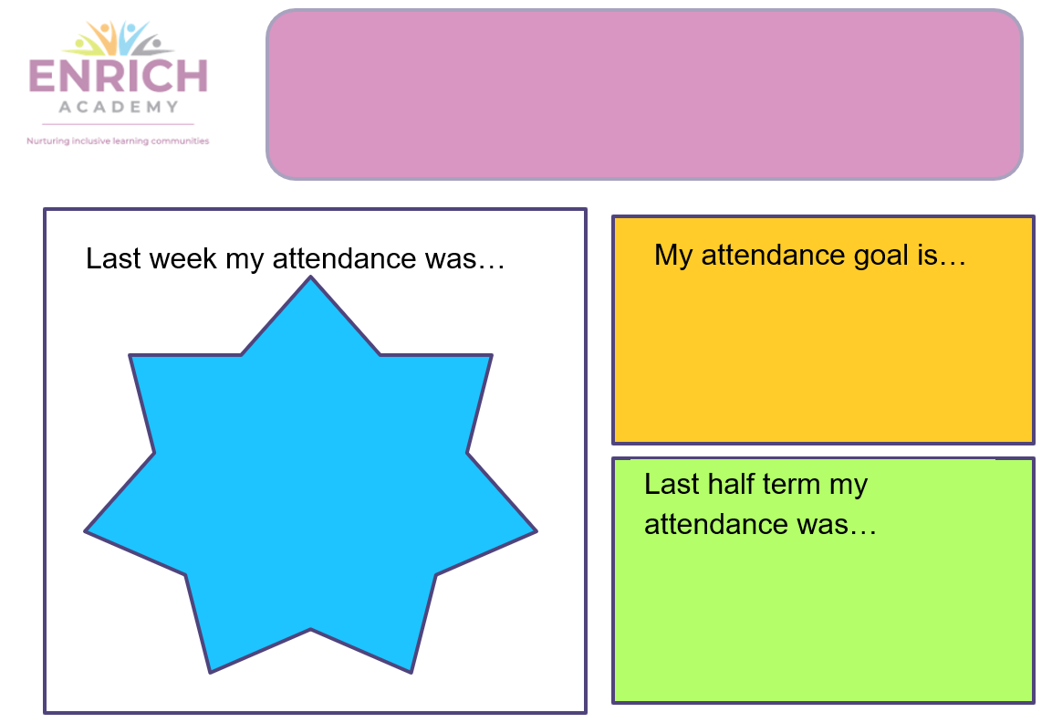

Appendix 4 – Attendance Improvement Plan
The purpose of the Student Attendance Improvement Plan is to identify the reason(s) for a student’s low attendance, document the previous steps taken by the school, and agree the plans necessary to improve the student’s future attendance. Review dates are a maximum of 4 weeks.
Student Name: |  |  | Parent/Carer Name:
Stage: (2,3,4) |  |  | Date of Plan:
Current Attendance: |  |  |  | Attendance Target:
 |  | Current barriers/reasons for attendance:
 |  | Actions:
Staff |  | Parent/carer | Student |  | Other
Review:
Attendance on review |  |  | Review Date
Staff sign |  |  | Student sign
Parent sign |  |  | Assistant Head Teacher sign

Appendix 5 – Part Timetable Arrangement

Student Name: |  | Year Group: |  | Stage on Attendance Plan: |  | Number of Review Cycles:
Is the student CLA
What is the student’s SEN status?
Does the student receive Pupil Premium?
Is the student subject to a Child Protection/Child in Need Plan?
Is the student’s first language English? If not, state their first language
Has a risk assessment been completed, and saved on Provision Map?

 | Start Date: |  |  |  |  |  |  | End Date:
 | Monday | Tuesday |  | Wednesday | Thursday | Friday | No. of hours in school |  | No. of hours provided outside of school | Brief overview of weekly progress
Week 1
Expected Start Time:
Expected Finish Time:
Week 2
Expected Start Time:
Expected Finish Time:
Week 3
Expected Start Time:
Expected Finish Time:
Week 4
Expected Start Time:
Expected Finish Time:
Week 5
Expected Start Time:
Expected Finish Time:
Week 6
Expected Start Time:
Expected Finish Time:

Rational behind part-time education for this pupil: (Highlight 3) |  |  | Type of education being provided outside of school during school hours:
To support mental health needs  To support medical needs (other than mental health)  Pregnancy/ Young parent  Staged Re-integration (new school)  Staged Re-integration (attendance issues)  Staged Re-integration (return from custody)  To focus on specific curriculum areas  To re-establish/ develop relationships with staff/ peers  To manage risks  To support emotional well being  Other, Specify:  NB Part timetables cannot be used to manage behaviour |  |  | Outreach Provision  EBSA support  ELSA support  Self Study (Online)  Self Study (Online with Supervision  Alternative Provision e.g. Keats  Other Intervention, Specify:
Feedback to be considered at the Provisions Meeting:
When completing the 6 weeks review, please ensure the feedback is shared with the following people and record any comments they make:
 | Name | Comments
Student
Parents/Carers
Designated Teacher in School for CLA (where necessary)
SENCO (where necessary)
Assistant Head Teacher/ DSL

Appendix 6 – Wakefield Attendance Strategy: Universal Attendance Procedure
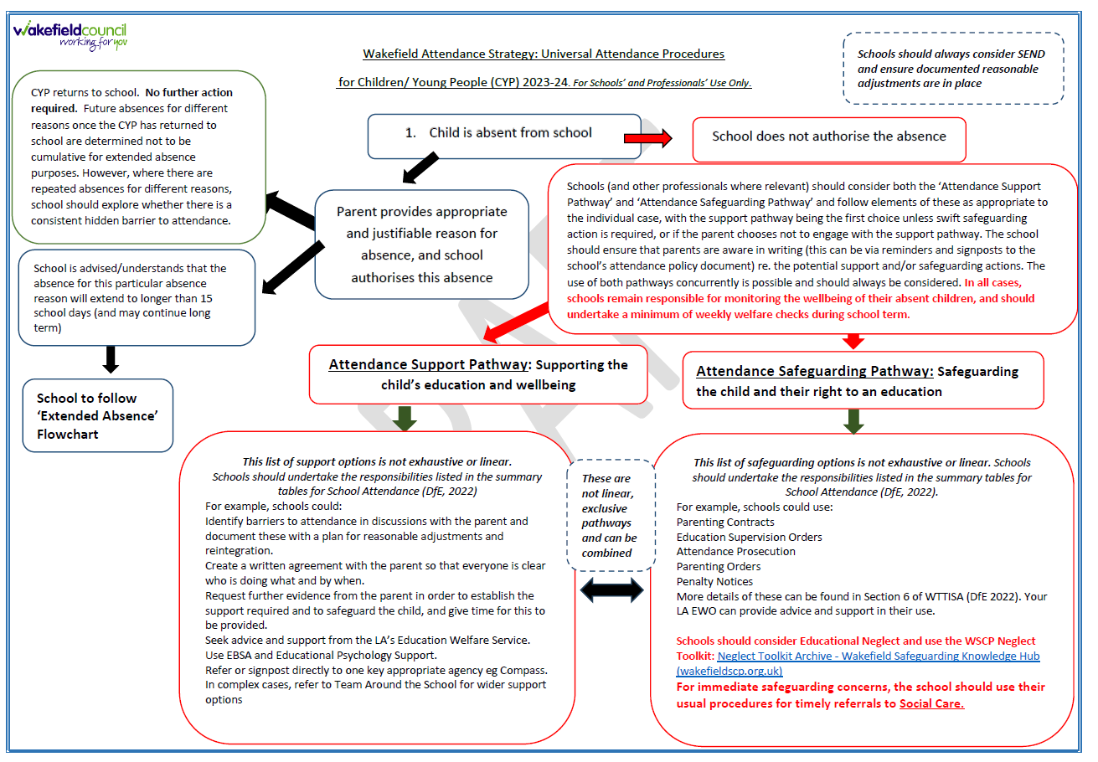

Appendix 7. Attendance Codes and when to use them

If a child arrives after registers close at 9:30, they be marked with an L code.
If a child is absent, parents/carers should inform the academy of the reason for the absence.
Elements Academy will record the absence under a particular category pre-set by the Department of Education (DfE). This data is then available to the attendance and pupil support service for each pupil. The DfE also receives annually the overall data for Elements Academy.

If a child is absent, parents/carers should contact the academy to provide a reason for absence. All calls and communications will be appropriately recorded by the academy. If the academy has not received contact, Family Support will attempt to make contact by 10.00. If contact cannot be made, a home visit will be carried out. See appendix A.

The following codes are used to record types of absence:
B - Educated off-site
T - Traveller absence
O - Unauthorised absence
/ - Present
N - No reason given
H - Agreed family holiday
G - Family holiday, not agreed
C - Other authorised circumstances
I - Illness
E - Exclusion
V - Educational trip
Y - Enforced closure
R - Religious observance
# - School closed to pupils
S - Study leave
W - Work experience
P - Sporting activity

It is the responsibility of the Assistant Head to ensure that registers are completed correctly. This responsibility may be delegated to the Attendance Officer, with the monitoring and oversight from the Assistant Head.

